|  |
| --- |
| User Manual  Samuda Inventory |
| REFERENCE: GW/ERP/USER MANUAL |
|  |
| **Genweb2 Ltd.** |
| **11-Apr-18** |



|  |
| --- |
|  |

# 

# Document Information

|  |  |
| --- | --- |
| Document Name | User manual for Inventory |
| Document Author | Rashedul Alam |
| Document Version | 1.3 |
| Release Date | 6th August, 2020 |

|  |  |
| --- | --- |
| 1st & 2nd Review by | Md. Matiar Rahman |
| Review Date | 12th April, 2018 |
| 3rd Review | Md. Mahfuzur Rahman |
| 3rd Review Date | 9th August 2020 |
| Approved By |  |
| Approval Date |  |

# Document History

|  |  |  |  |  |  |
| --- | --- | --- | --- | --- | --- |
| A=Added, M=Modified, D=Delete | | | | | |
| **Version No** | **Date** | **Section No** | **A/M/D** | **Description of Change** | **Author** |
| 1.0 | 11-April-2018 |  | A | Initial | Rashedul Alam |
| 1.1 | 17-April-2018 |  | A | Gate in | Rashedul Alam |
| 1.2 | 14-May-2018 |  | A | Warehouse, Location, Operation type, Units of measure, Receive goods, Quality control, Sound stock, MRR, Product Hands on, Inventory Dashboard, Item loan lending, Item loan borrowing, Scrap, All Inventory reports. | Rashedul Alam |
| 1.3 | 5-Aug-2020 |  | A/M | New image add, new reports add,Add some text & Modify. | Rashedul Alam |

Contents

A. Document Information 2

B. Document History 2

1. Introduction 5

1.1 Purpose of User manual 5

2. Indents 5

2.1 Indent raise by employee 6

2.2. Indents approval 8

2.2.1 Indents approval by Indent approver 8

3. Issue Products 9

3.1 Issue Product creation by Inventory Manager 9

3.2 Partial Issue Product creation by Inventory manager 11

4. Issue PR 12

4.1 Issue PR Creation with indent by Inventory user or Manager 12

4.2 PR Creation without indent by Inventory user or Manager 13

4.3 PR Validate by Plant In charge 14

4.4 PR approval by Head of procurement 15

5. Gate in 17

5.1 Create Gate in by Gate in Approver 17

6. Receive goods 19

6.1 Receive goods create by Inventory Manager 19

6.2 Partial Receive goods creation by Inventory manager 20

7. Quality Control 21

7.1 Quality Control create by Inventory user/Inventory Manager 22

7.2 Partial Quality control creation by Inventory manager 23

8. Sound stock 24

8.1 Sound stock Update by Inventory Manager 24

8.2 Partial Sound stock creation by Inventory manager 26

9. MRR (Accounts approver) 27

9.1 MRR (Accounts approver) Approved by MRR Accounts Approver 27

9.2 MRR (Final accounts approver) Approved by Plant in charge 28

10. Print MRR 29

10.1 Print MRR View by Plant In charge 29

11. Product on Hands 31

11.1 View on Hands product Inventory Manager 31

12. Inventory Dashboard 31

12.1 Inventory dashboard view by Inventory Manager 31

13. Item loan lending 32

13.1 Item loan lending create by Inventory Manager 32

13.2 Item loan lending Approved by Inventory Manager 33

14. Item Borrowing 34

14.1 Item Borrowing create by Inventory Manager 34

14.2 Item Borrowing Approved by Inventory Manager 35

15. Scrap 36

15.1 Scrap create by Inventory Manager 37

15.2 Scrap Approved by Inventory Manager 37

16. Reports 38

16.1 PR Summary view by Inventory manager 38

16.2 Stock Summary view by Inventory user/manager 40

16.3 Purchase reports view by Inventory user/manager 41

16.4 Loan Lending Reports view by Inventory user/manager 42

16.5 Loan Borrowing Reports view by Inventory user/manager 44

16.6 Stock Transfer view by Inventory user/manager 47

16.7 Stock Consumption reports view by Inventory user/manager 48

16.8 Stock Issue reports view by Inventory user/manager 49

16.9 Stock Issue Due reports view by Inventory user/manager 50

# 1. **Introduction**

The purposes of this User manual are to clearly identify the customer requirements and provide a detailed document. The customer will read this document and get a clear view the sales module. It will also help the review team to validate whether the customer requirements have been fulfilled or not.

## Purpose of User manual

The purpose of this User Manual is to clearly identify the customer requirements and provide a detailed document. The customer will read this document and get a clear view of the Commercial module. It will also help the review team to validate whether the customer requirements have been fulfilled or not.

# 2. Indents

Each and every Employee will raise indent and Indent approver will approve indents.

If available stock then indent will go for issue indent and will go done state.

If stock not available then will go for Issue PR and it’s another process.

**Indent no:** System will generate auto a unique no after indent creation. Here will first operating number then Year then unique a number.

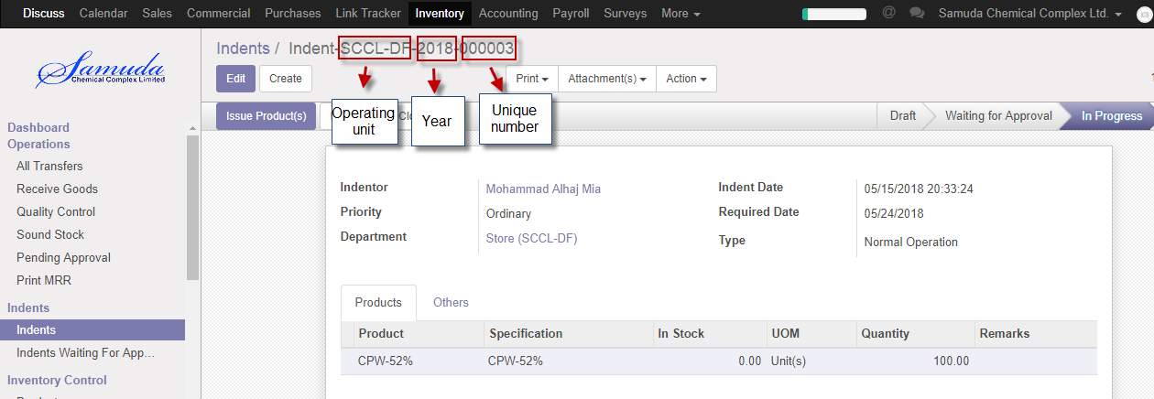

Figure: Indent number

**Indent Search:** Employee is capable to Search indent with variant combination like; with indent no, Company, Department wise etc.

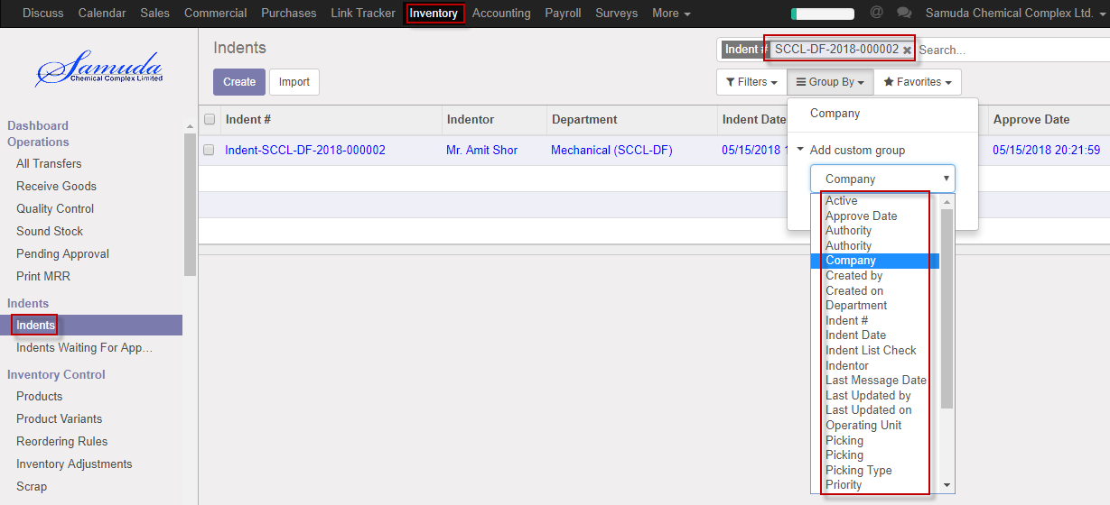

Figure: Indent Search

## 2.1 Indent raise by employee

Indent will be created/Edit by employee

Indent manager/each employee can raise Indent using the menu **Inventory ‣ indents** and click **Create.**

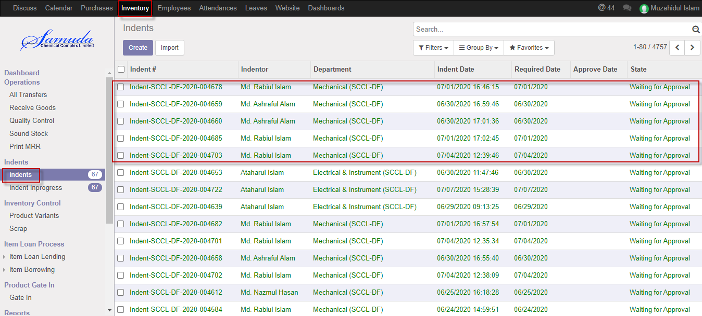

Figure: Indents List view

We need to set the following:-

**Priority**: Select priority.

**Required date:** Select required date.

**Type:** Select type.

**Product:** Select product.

**Quantity:** Select qty.

After entering all information click **Save & Confirm**.

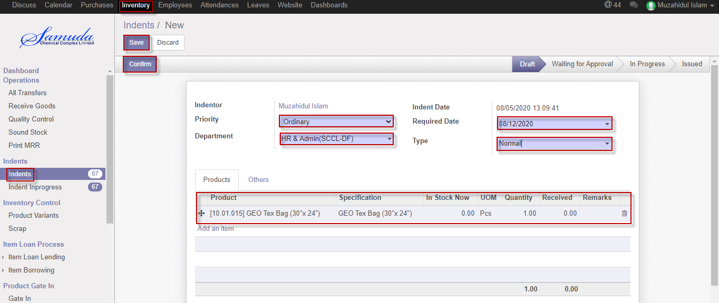

Figure: Create Indents

# 2.2. Indents approval

Each and every indent user will raise indent and Indent approver will approve indents.

## 2.2.1 Indents approval by Indent approver

After raise the Indents, Indents approver will get the notification. He/she can update before approve if require.

To see the Pending indents use the menu **Inventory ‣ Indents>>Indents waiting for approval**

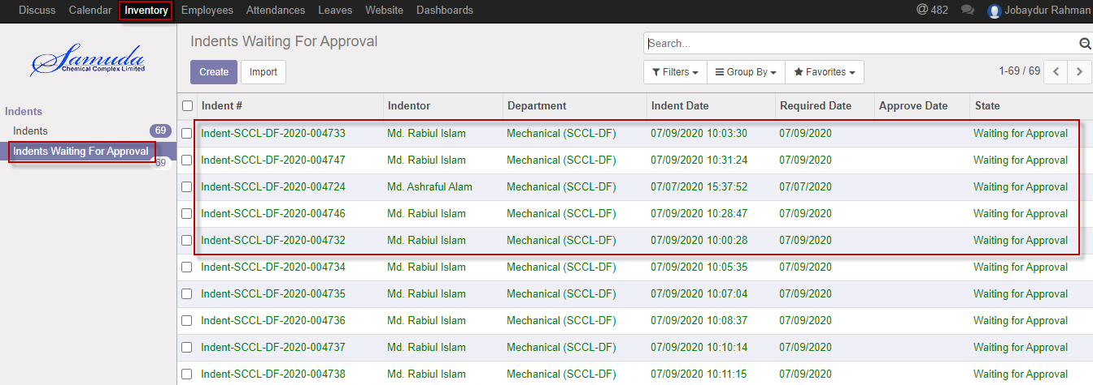

Figure: Indents waiting for approval list view

Indent approver can approve. Select an indent from list then click on **Approve** button 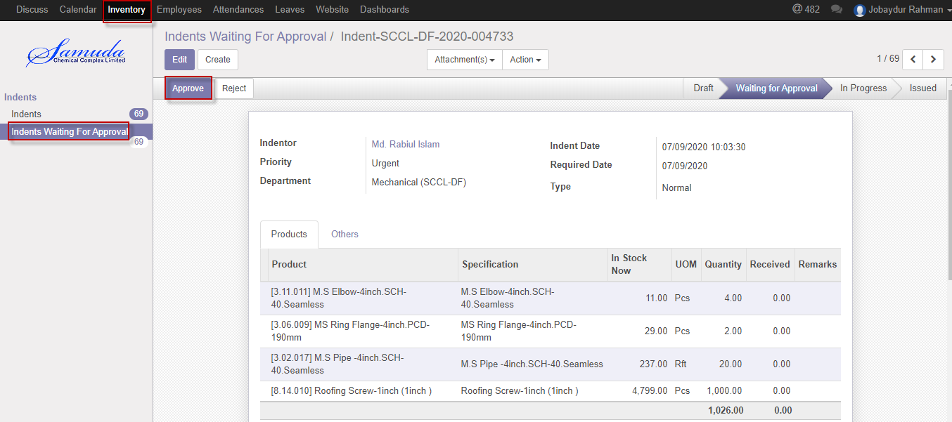

Figure: Indents approved

Indents approver is capable to reject indent by click **Reject** Button.

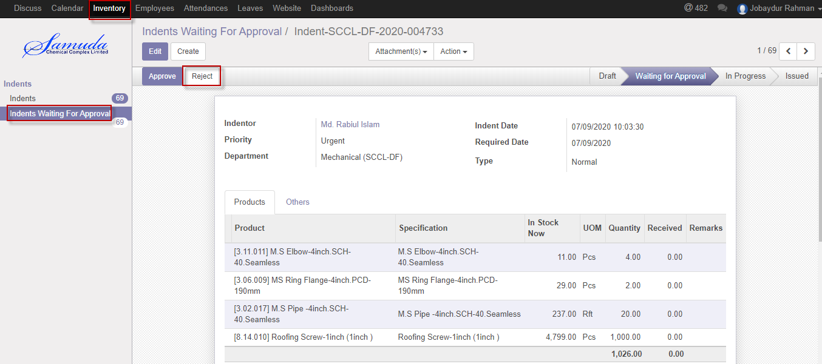

Figure: Indents reject

# 3. Issue Products

If product is available in stock then will go for issue product. Inventory manager will create issue product.

## 3.1 Issue Product creation by Inventory Manager

Issue Products will be created/Edit by Inventory manager.

Inventory manager can create Issue Product using the menu **Inventory ‣ indent inprogress** >>**Issue Product>>** click **Issue product** Button**.**

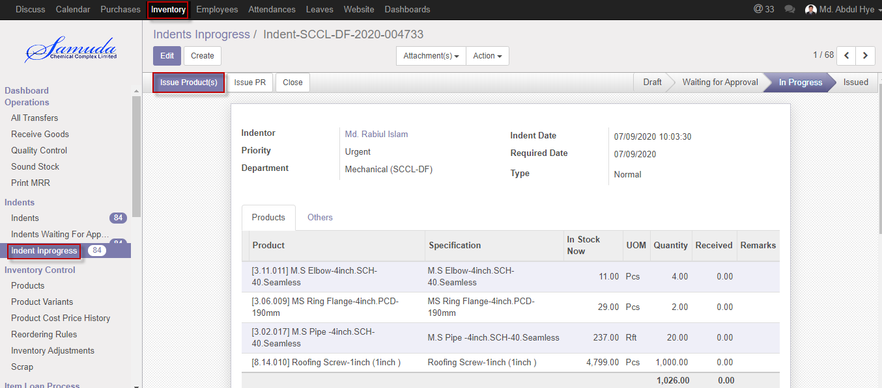

Figure: Create Issue Product

After click validate button will open Yes/No pop up alert then Click **Validate button** then finally issue product will go for done state.

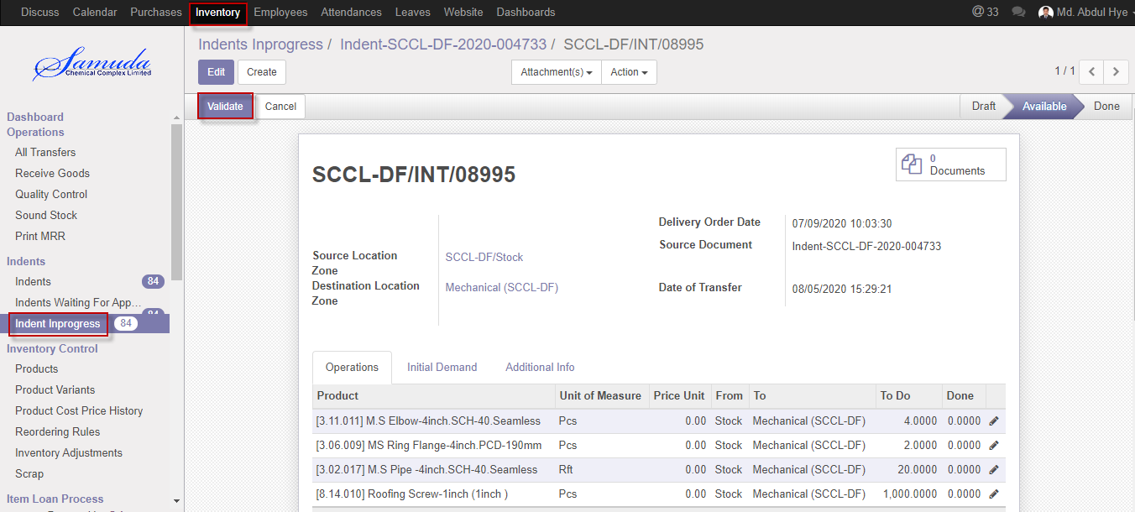

Figure: Validate

Cancel issue product with click **Cancel button.**

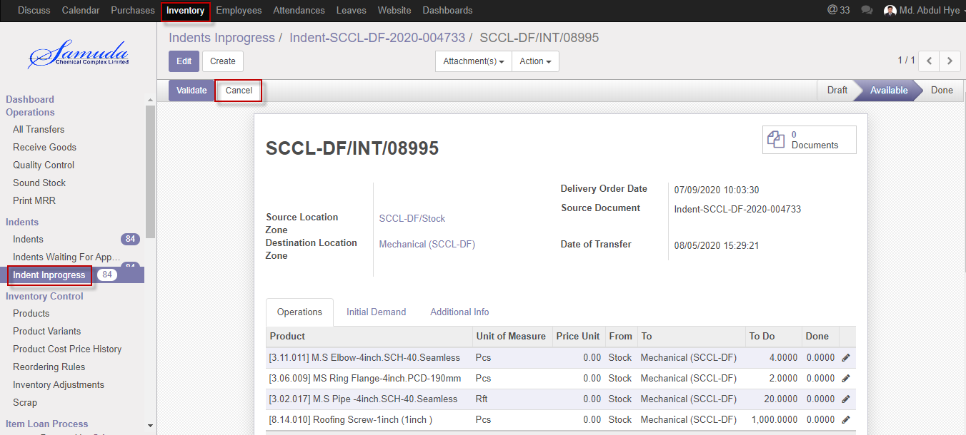

Figure: Cancel issue product

## 3.2 Partial Issue Product creation by Inventory manager

Inventory manager will capable to partial issue product and then will create Backorder.

Inventory manager can create Partial Issue Product using the menu **Inventory ‣ indent in progress** >>**Issue Product>>** click **Issue product** Button**.**

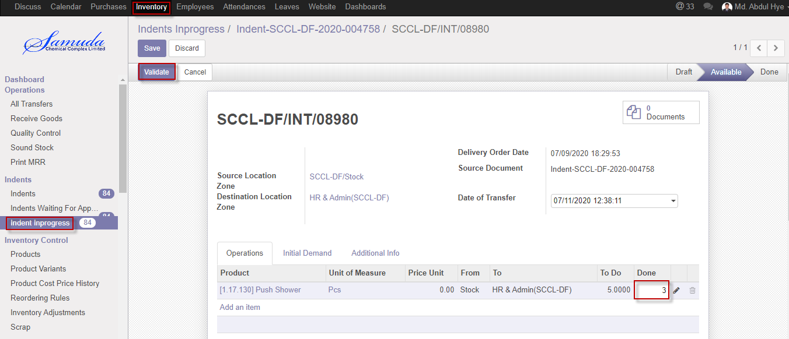

Figure: Partial Issue Product

After click Validate button will open Backorder window then Click **Backorder** buttonthen finally Backorder will go create.

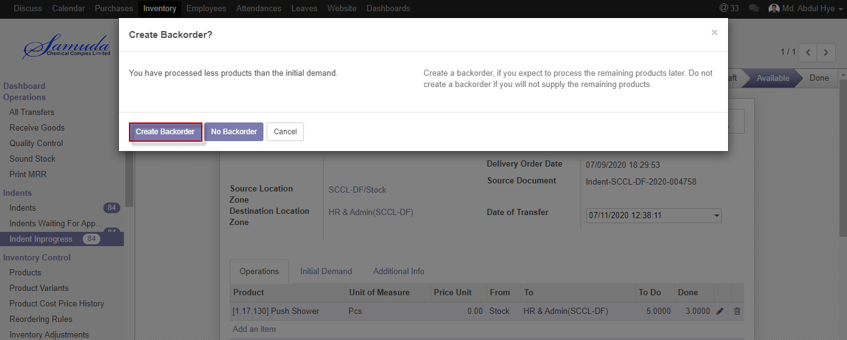

Figure: Create Backorder

# 4. Issue PR

**PR Number:** System will generate auto a unique PR no after Issue. Here will first operating number then Year then unique a number.

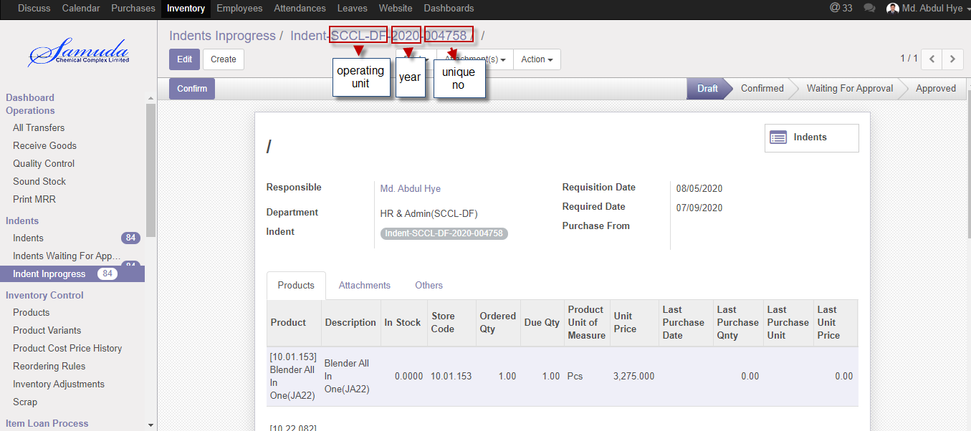

Figure: PR no

## 4.1 Issue PR Creation with indent by Inventory user or Manager

Issue PR will be created/Edit by Inventory user/Manager.

Issue PR is possible for with indent and without indent

PR is possible with multiple indents if user want.PR no has system generated.

Inventory manager/user can create Issue PR using the menu **Inventory ‣ indent in progress**>>**Issue PR click & Confirm.**

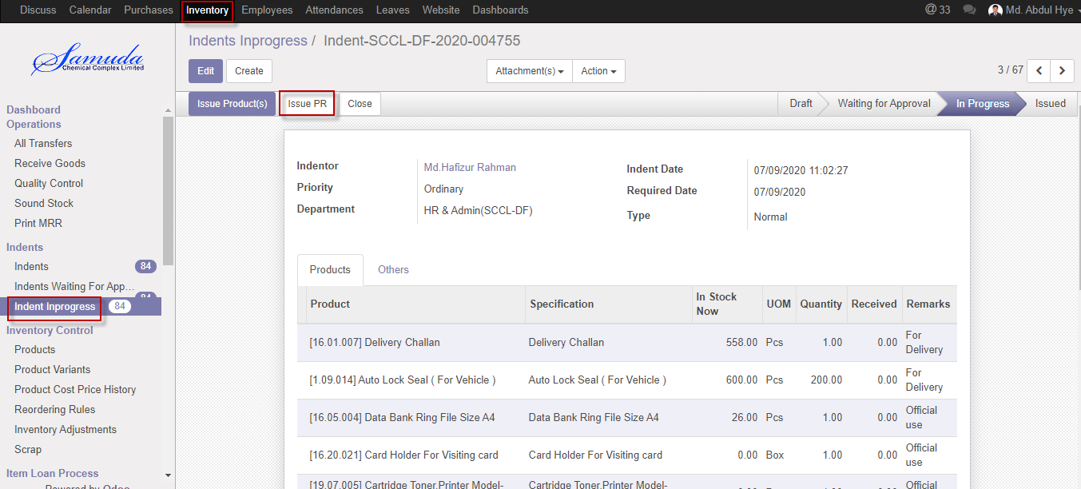

Figure: Issue PR Creation

## 4.2 PR Creation without indent by Inventory user or Manager

PR Without indent will be created/Edit by Inventory user/Manager.

Inventory manager/user can create PR without indent using the menu **Purchase ‣ Purchase** **>>Purchase requisition>>Save & Confirm.**

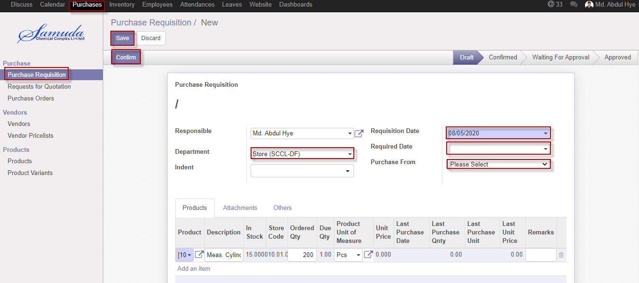

Figure: PR Creation without indent

## 4.3 PR Validate by Plant In charge

Validate PR by click **Validate** Button. Validate by Plant in charge.

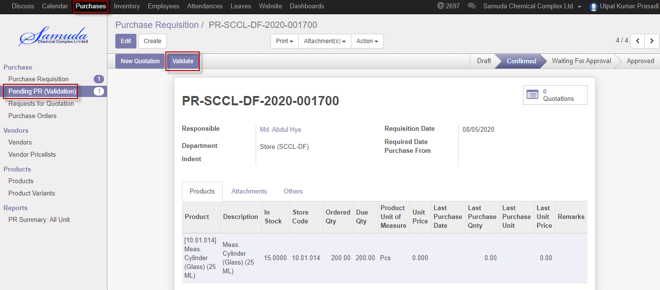

Figure: PR validate

After click Validate button will open following window then Select purchase from, Region type, Purchase By and then **save**

If select own then will go for Issue IoU and select HO then will go for HO procurement for Final approve**.**

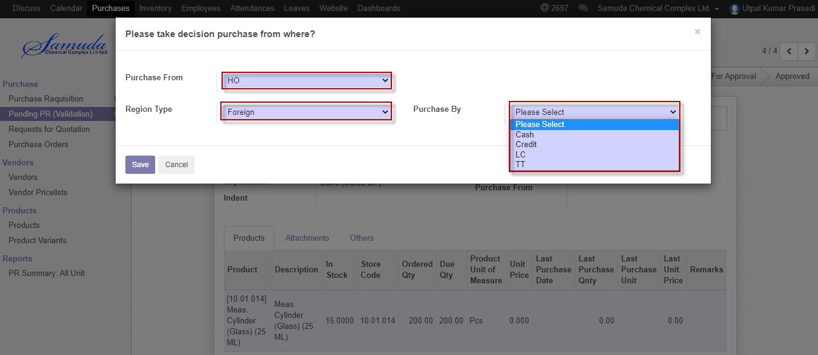

Figure: Purchase from window

## 4.4 PR approval by Head of procurement

After Validate the PR Head of Procurement will get the notification. He/she can approve to see use the menu **Purchases ‣ Purchase>>Pending PR (Approved)** Click **Approve**

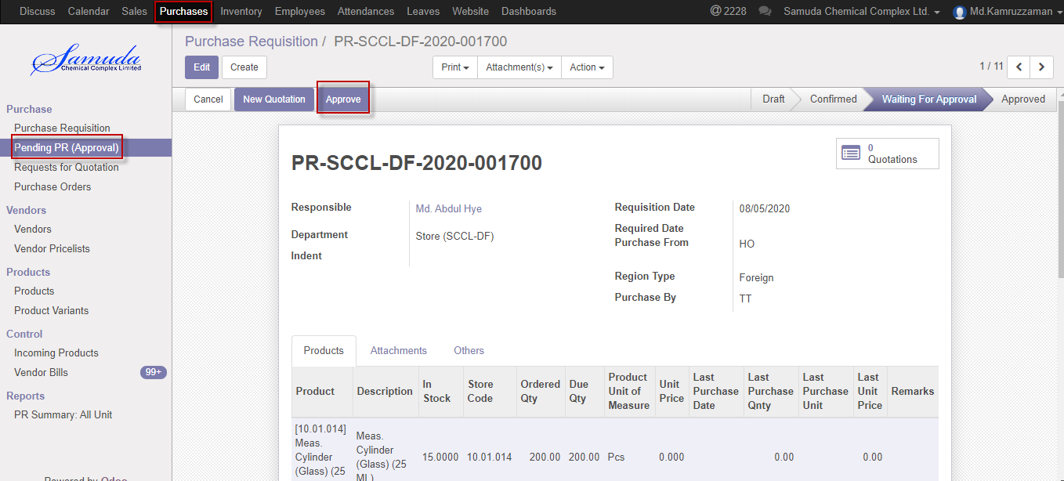

Figure: Pending PR waiting for approval

Following window will open after click **Approve** button then select region type & Purchase by

Select region type Local or Foreign and also will select Purchase by which method Cash,Credit,LC or TT. 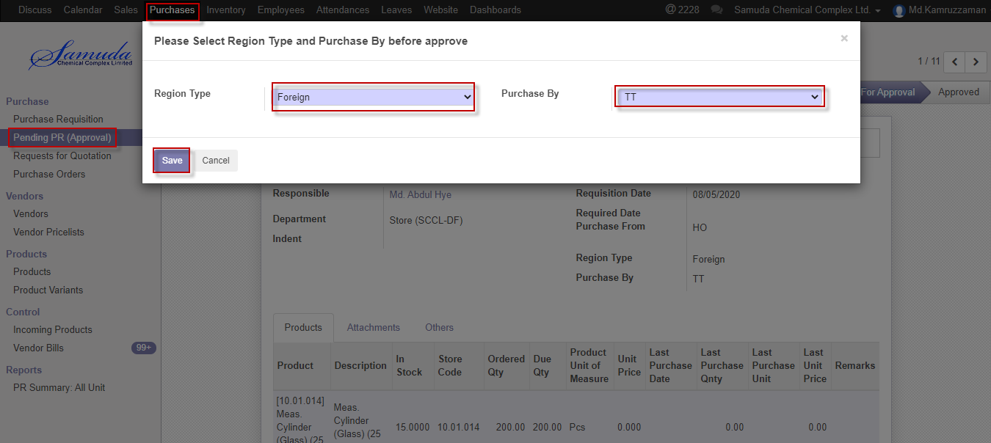

Figure: Purchase method

Following window will open after click **save** button then will ready for New Quotation .New quotation Approve by Head of procurement. 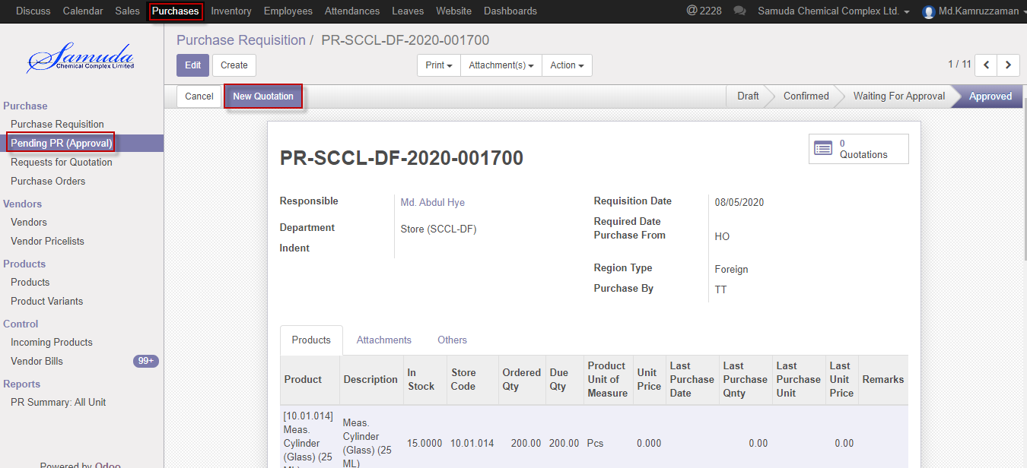

Figure: Create new quotation

Click New quotation button & Select supplier after select all info will come auto and head of procurement is capable to edit then Click **Confirm order** button. Confirmed By Head of Procurement.

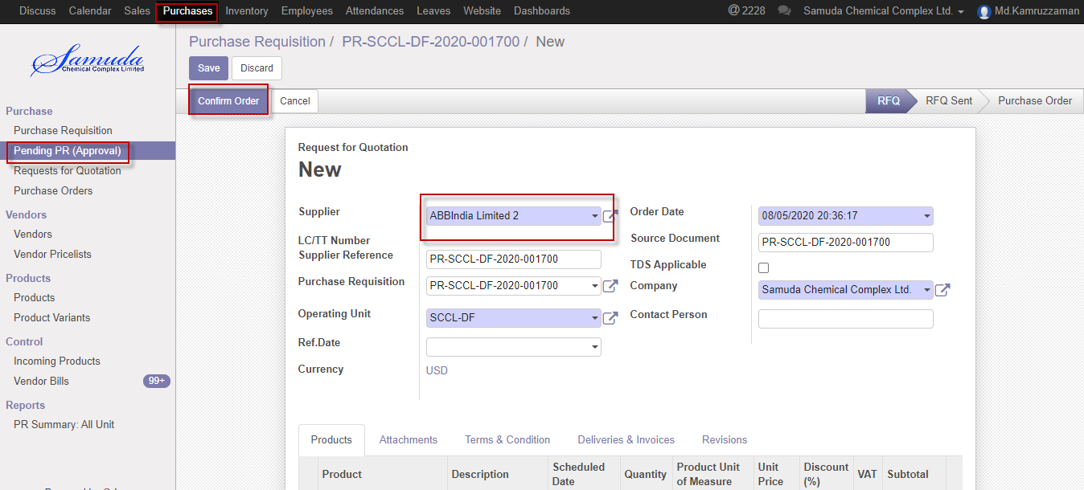

Figure: Confirm order

Following window will open after click Confirm order Button then select region type & purchase by then save then Click Purchase order button then finally Purchase order will approve.

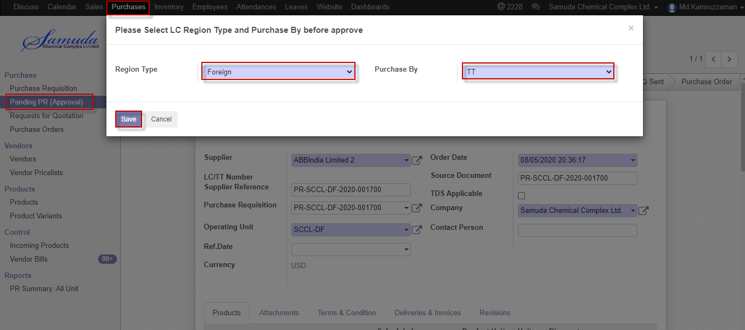

Figure: Purchase method

# 5. Gate in

## 5.1 Create Gate in by Gate in Approver

Gate in will be created/Edit by Gate in approver

Gate in Approver can create Gate in using the menu **Inventory ‣ Product Gate in>>Gate in** and click **Create.**

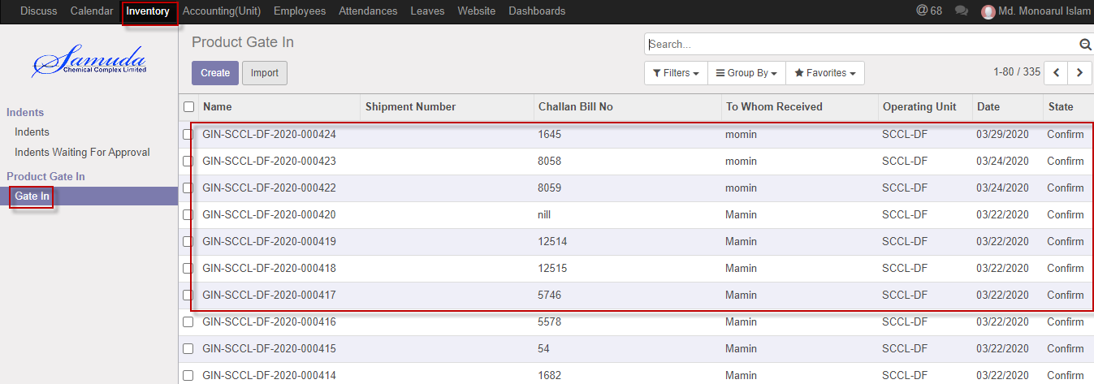

Figure: Gate in List view

We need to set the following:-

**Receive type**: Select receive type.

**Date:** Select date.

**Challan bill no:** Enter challan bill no.

**Track/Vehicle no:** Enter Track/Vehicle no.

**Shipment No:** Select Shipment no.

**Carried By:** Enter carried by.

**To whom received:** Enter to whom received

After entering all information click **Save & Confirm**.

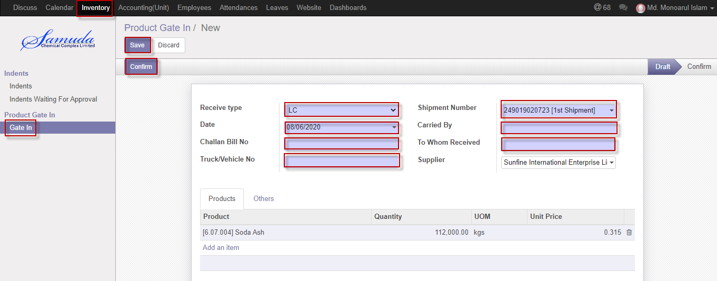

Figure: Create Gate in

# 6. Receive goods

Receive goods are possible for below cases:

Receive goods against purchase order

Receive goods against a loan

Receive goods against a loan return

Receive goods against faulty goods (Optional)

Receive goods against LC

Receive goods against others

## 6.1 Receive goods create by Inventory Manager

Receive goods will be created/Edit by Inventory manager

Receive goods create using the menu **Inventory ‣ operations>>Receive goods** and click **Create.**

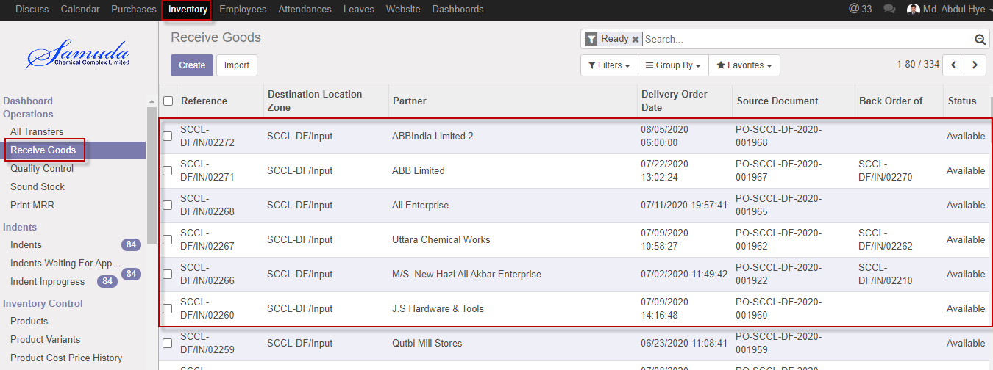

Figure: Receive goods List view

We need to set the following:-

Select goods from list item then receive click **Receive goods button**

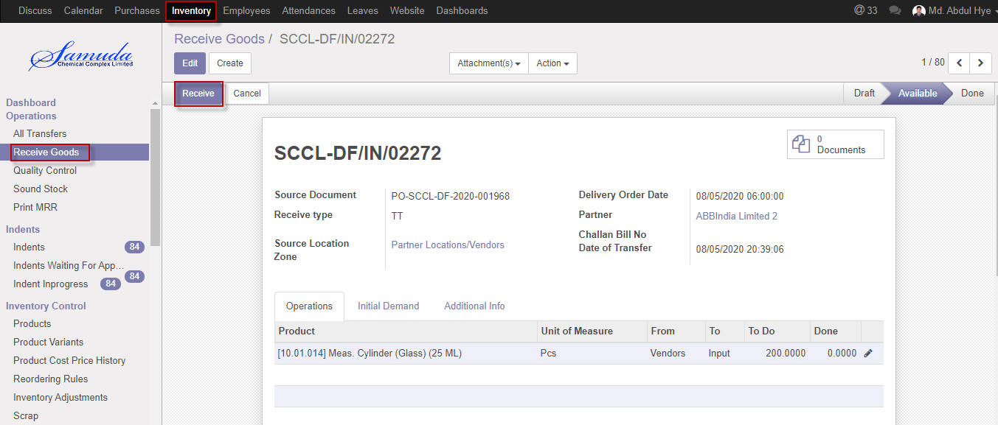

Figure: Receive goods

Cancel Receive goods with click **Cancel button.**

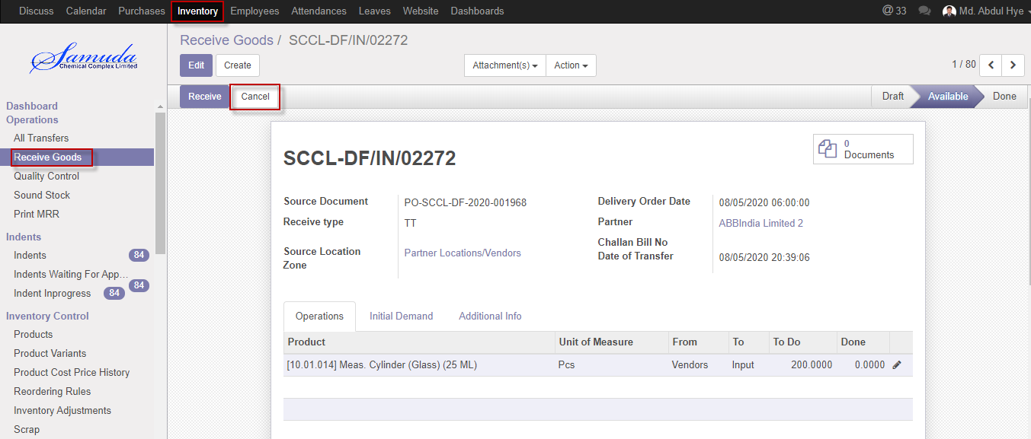

Figure: Cancel receive goods

## 6.2 Partial Receive goods creation by Inventory manager

Inventory manager will capable to partial receive goods and then will create Backorder.

Inventory manager can create Partial Issue receive goods using the menu **Inventory ‣ Operation** >>**Receive goods>>** click **Receive goods** Button**.**

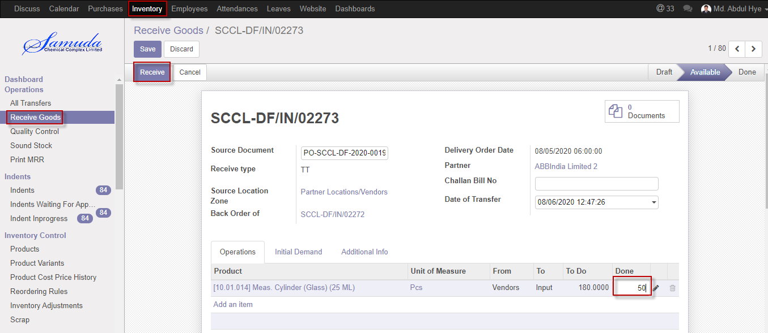

Figure: Partial receive goods

After click Receive button will open Backorder window then Click **Backorder** buttonthen finally Backorder will go create and receive will done.

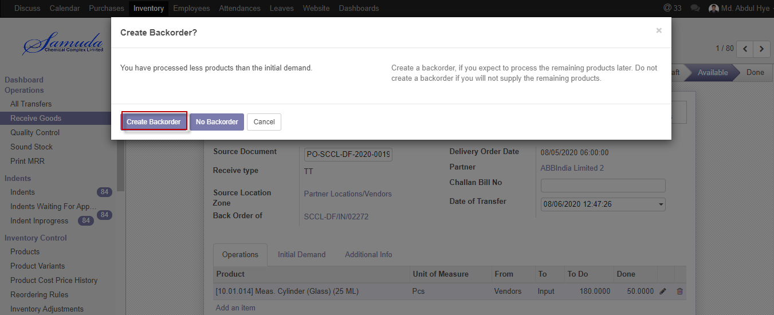

Figure: Create Backorder

# 7. Quality Control

Store keeper receives goods which was sent by supplier. QC Authority checks the quality and quantity of goods as per Order. According to QC result they take necessary decision.

If goods are in good quality and exact quantity then QC accept the goods and update the stock of the goods.

If goods are not acceptable and not in exact quantity/quality, QC authority returns the rejected goods to Store Keeper for receive return to Supplier.

## 7.1 Quality Control create by Inventory user/Inventory Manager

Quality control will be Validate/Edit by Inventory manager

Quality control validate using the menu **Inventory ‣ operations>>Quality Control** and click **Validate.**

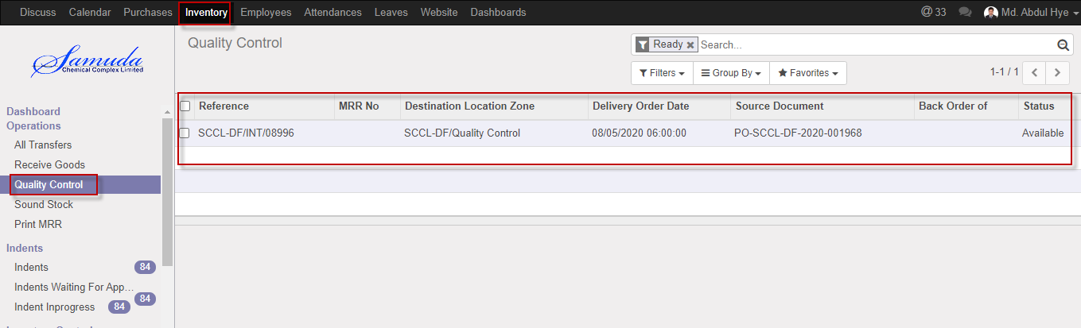

Figure: Quality control List view

We need to set the following:-

**Validate**: Click Validate button.

Quality control validate will done after click the validate button

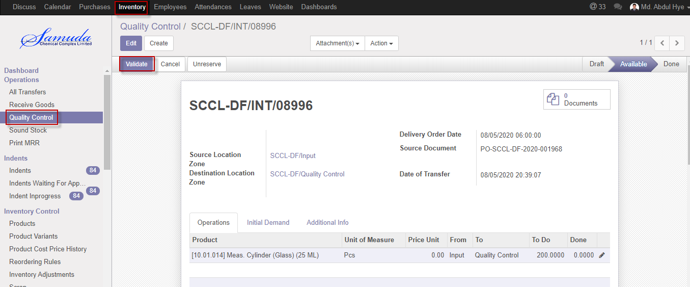

Figure: Quality control validate

Cancel Quality control with click **Cancel button.**

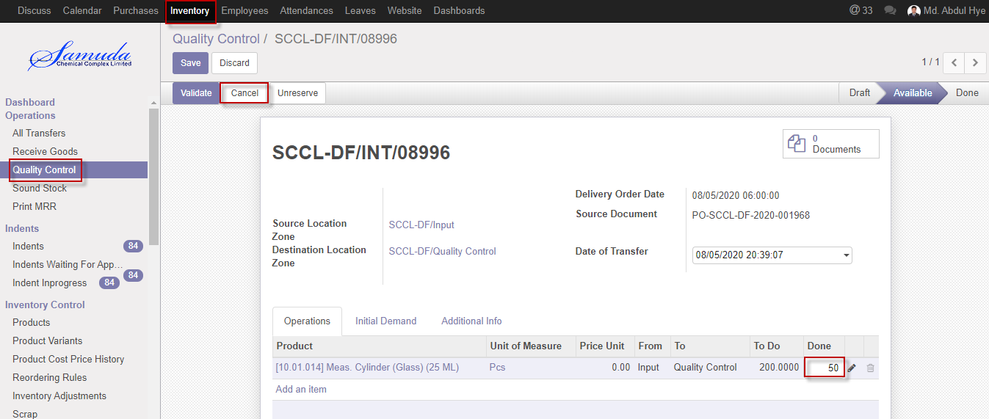

Figure: Cancel Quality control

## 

## 7.2 Partial Quality control creation by Inventory manager

Inventory manager will capable to partial quality control and then will create Backorder.

Inventory manager can create Partial quality control using the menu **Inventory ‣ Operation** >>**Quality control>>** click **Validate** Button**.**

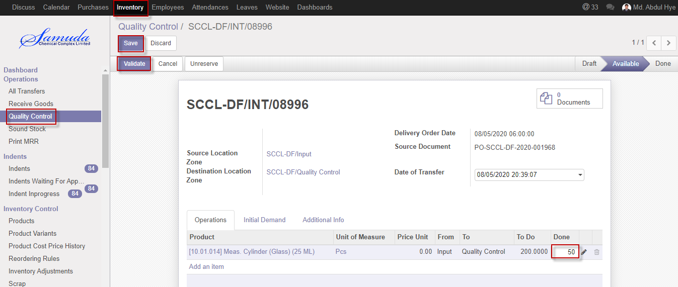

Figure: Partial QC

After click Validate button will open Backorder window then Click **Backorder** buttonthen finally Backorder will go create and QC will done.

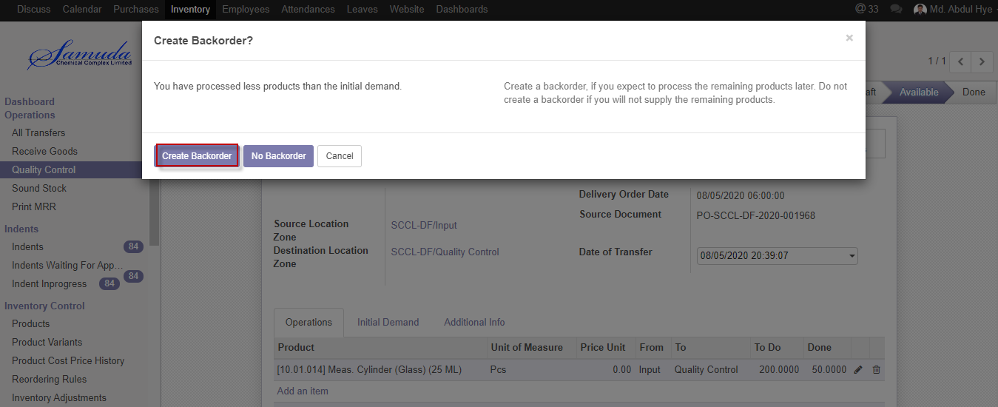

Figure: Create Backorder

# 8. Sound stock

Data will come in sound stock after Quality received. Main stock will be updated after sound stock received.

## 8.1 Sound stock Update by Inventory Manager

Sound stock will be Updated/Edit by Inventory manager

Sound stock updated using the menu **Inventory ‣ operations>>Sound stock** and click **Validate.**

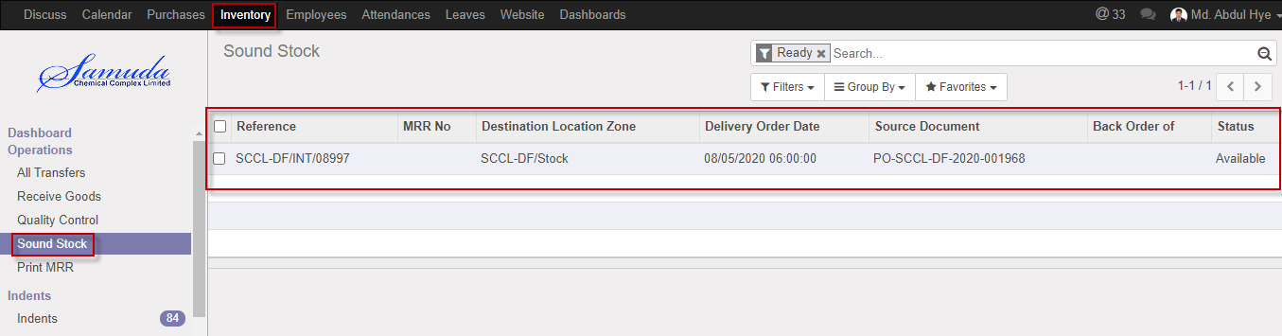

Figure: Sound stock List view

We need to set the following:-

**Validate**: Click Validate button.

Sound Stock validate will done after click the validate button

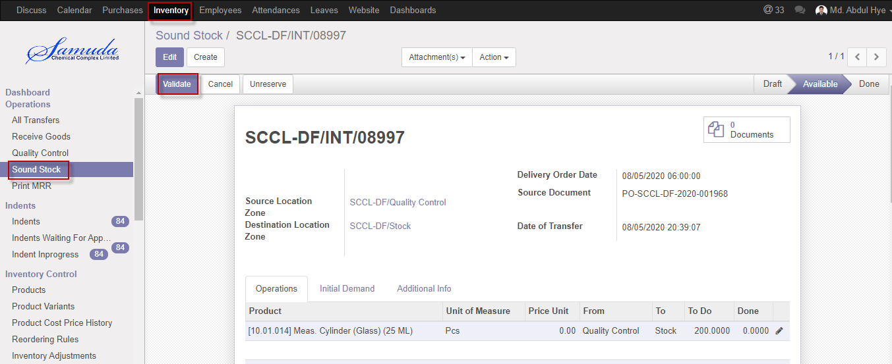

Figure: Validate sound stock

Cancel Sound stock with click **Cancel button.**

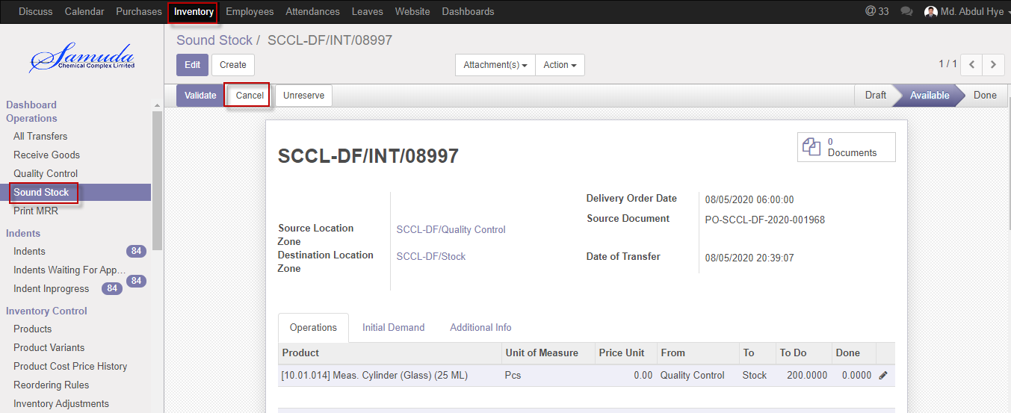

Figure: Cancel Sound stock

## 8.2 Partial Sound stock creation by Inventory manager

Inventory manager will capable to partial Sound stock and then will create Backorder.

Inventory manager can create Partial Sound stock using the menu **Inventory ‣ Operation** >>**Sound stock>>** click **Validate** Button**.**

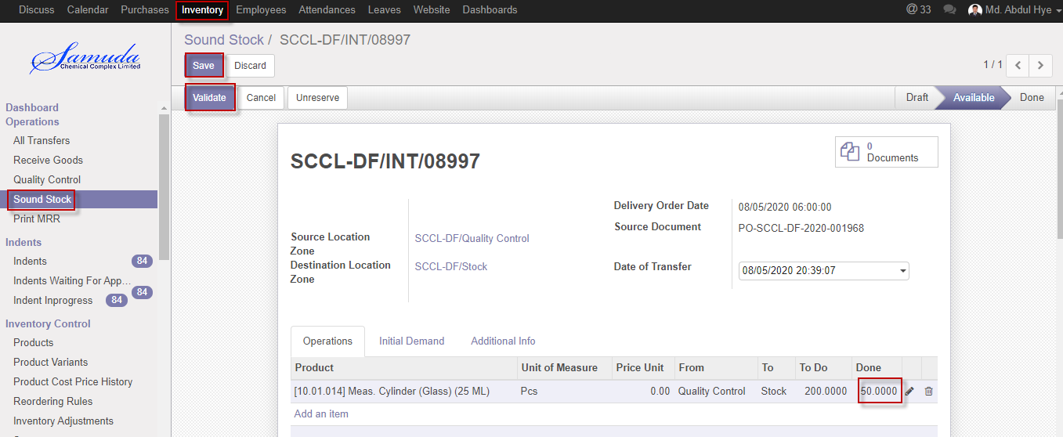

Figure: Partial Sound stock

After click Validate button will open Backorder window then Click **Backorder** buttonthen finally Backorder will go create and Sound stock will update.

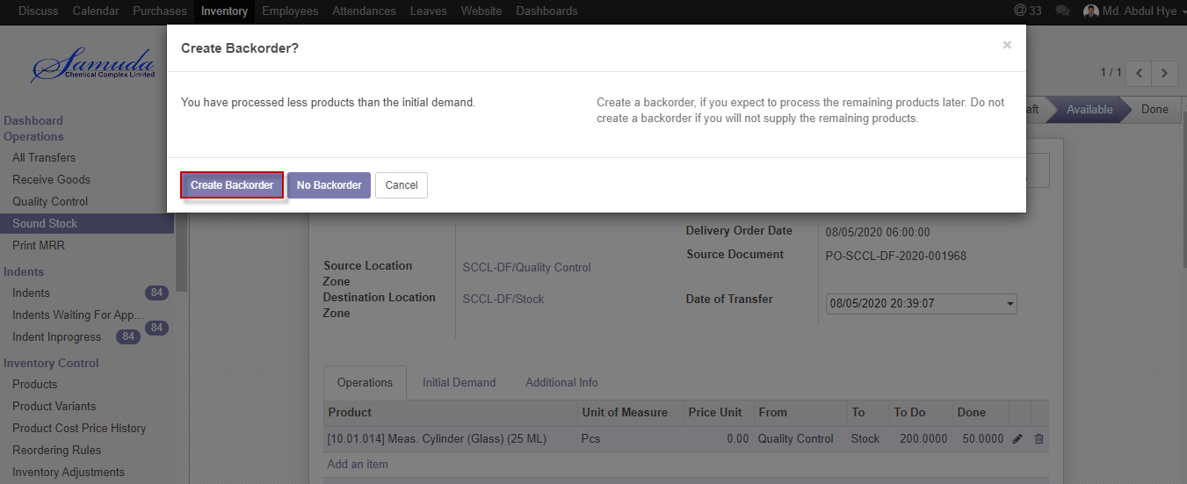

Figure: Create Backorder

# 9. MRR (Accounts approver)

MRR accounts approve will open after sound stock update and then accounts approval show MRR will open. Plant in charge will view show MRR report after Accounts approve.

## 9.1 MRR (Accounts approver) Approved by MRR Accounts Approver

After sound stock update and AC (account) approval MRR will open.

MRR Accounts approve using the menu **Accounting (unit) ‣ Inventory>>Account Approver** and click **AC Approve.**

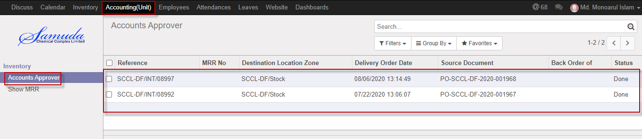

Figure: AC Approve List view

We need to set the following:-

Select a MRR from list then click **AC Approve**

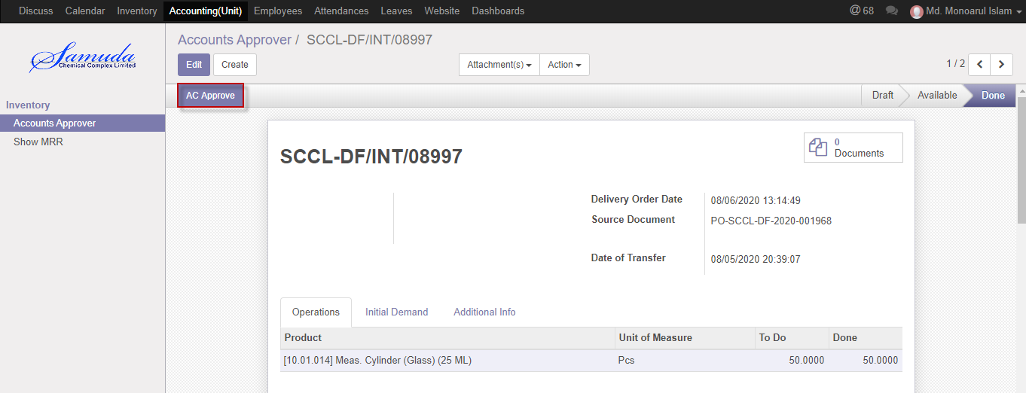

Figure: AC Approve

## 9.2 MRR (Final accounts approver) Approved by Plant in charge

After AC approver Final approves will ready for plant In charge.

MRR Final Accounts approve using the menu **Inventory‣ Operations>>Pending Approval** and click **Approve.**

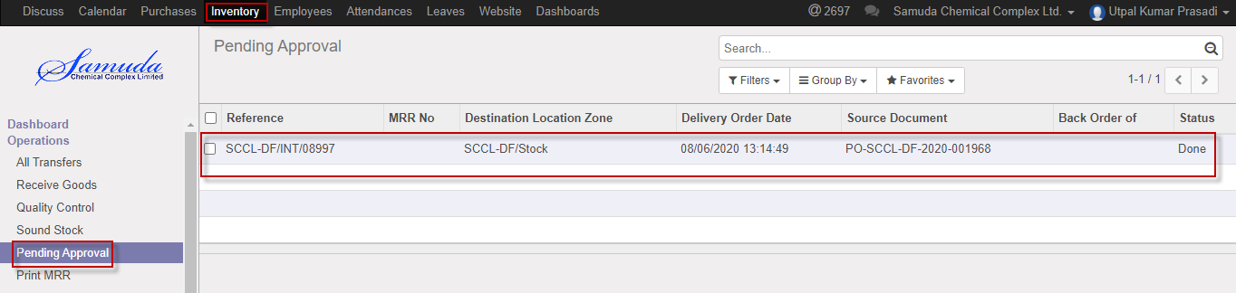

Figure: Pending Approval List view

We need to set the following:-

Select a MRR from list then click **Approve**

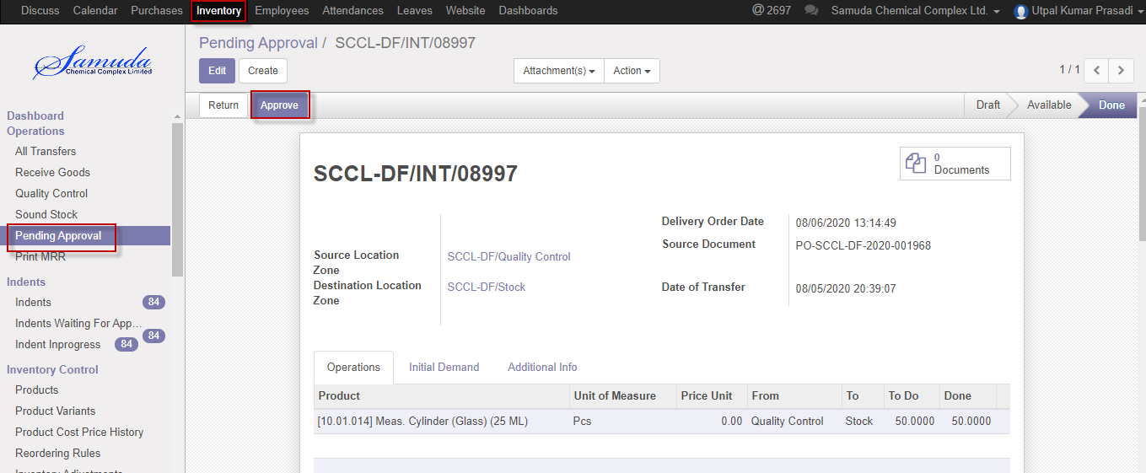

Figure: Pending Approval

# 10. Print MRR

A material receiving report (MRR) is an internal document used to record what materials and inventories were received by the company. The receiving report is sent to other departments to notify them what items have been received and are ready for use. This form is completed immediately upon receipt of materials, supplies, or services. The person receiving the goods will prepare this report. Industry receives all goods by preparing a Material Receiving Repot (MRR).

## 10.1 Print MRR View by Plant In charge

After sound stock update and AC (account) approval MRR will open.

View MRR using the menu **Inventory ‣ operations>>Print MRR** and click **Print MRR.**

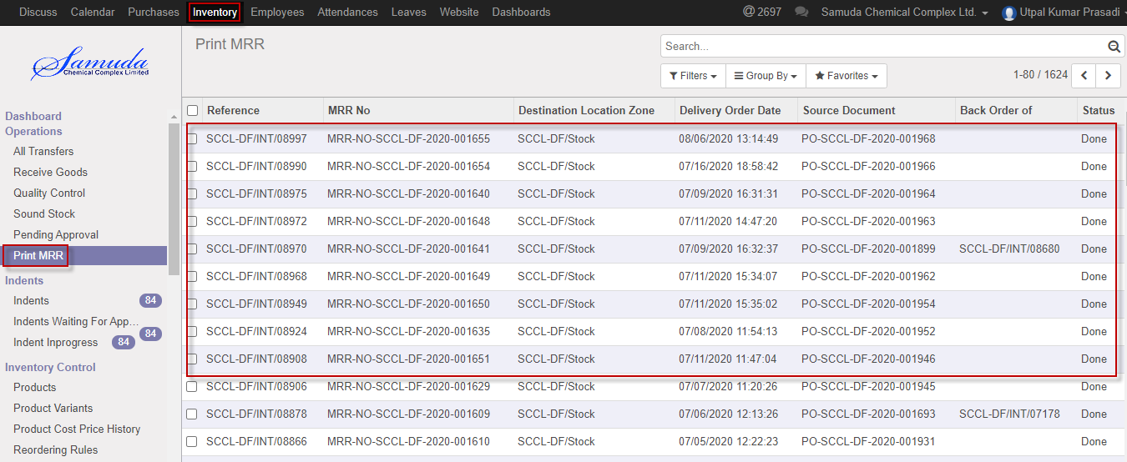

Figure: Print MRR List view

We need to set the following:-

Select a Print MRR from list then click **Print MRR**

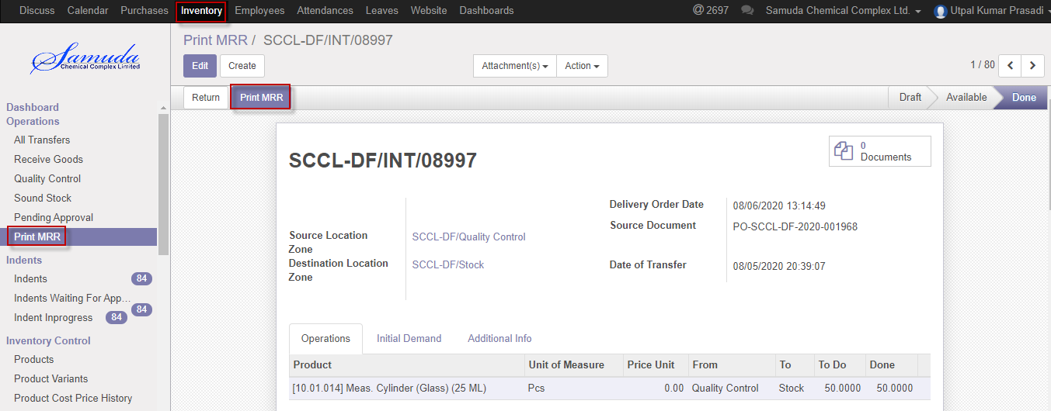

Figure: Print MRR

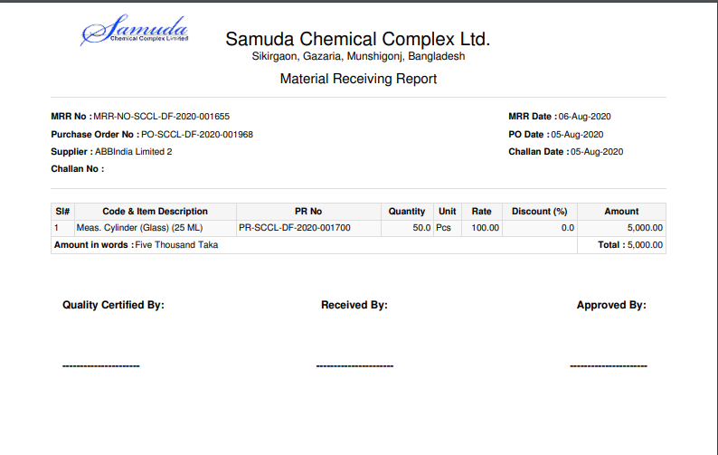

Figure: Print MRR pdf format

# 11. Product on Hands

Product's quantity on hand, it can be retrieved from qty available (Quantity On Hand) field of the Product.  It is a calculated field.  To update, you cannot directly update the qty available field, because it is a calculated field.  You need to actually create a stock move to account for the quantity difference.  Another way it from the Update button next to the qty available field which in turn will call the stock changes. Product qty wizard that will create the new stock. Move.

## 11.1 View on Hands product Inventory Manager

Inventory manager will go product then will view on hands product.

Inventory Manager will view using the menu **Inventory ‣ Products>>** and click **Product.**

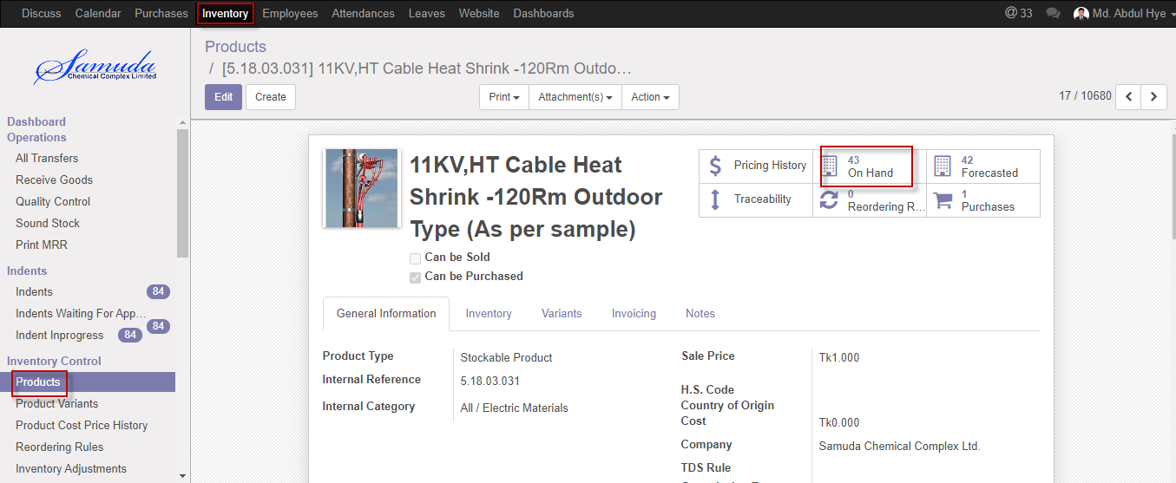

Figure: Product on hands

# 12. Inventory Dashboard

Receive goods, internal transfer, Delivery order will view here.

## 12.1 Inventory dashboard view by Inventory Manager

Inventory Dashboard will view using the menu **Inventory ‣ Dashboard>>** and View**.**

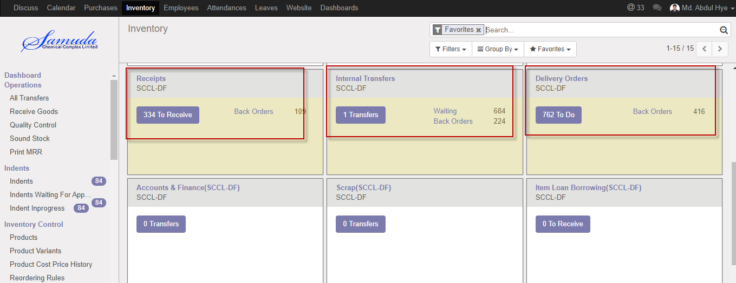

Figure: Inventory Dashboard

**Receipts:** After any product receive will view here.

**Internal transfer:** For Stock move product will view here.

**Delivery order:** Product will view here for Stock delivery.

# 13. Item loan lending

Store keeper will receive loan request for items/goods from other company. Plant Manager will approve the loan request. Goods will be delivered to the other company in mentioned location and it will have gate pass out process as well. The stock will be update automatically when items are delivered to other company.

## 13.1 Item loan lending create by Inventory Manager

Item Loan lending will be Created/Edit by Inventory manager.

After loan lending Product qty will deduct from Main stock.

Item loan lending created using the menu **Inventory ‣ Item loan process>>Item loan lending** and click **Create.**

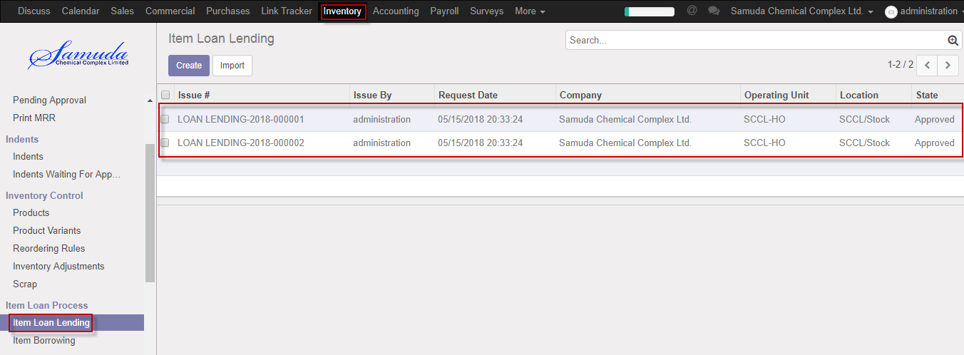

Figure: Item loan lending List view

We need to set the following:-

**Requested by**: Select requested by.

**Product:** Select product, after select other info will come auto.

After entering all information clicks **Save and confirm**.

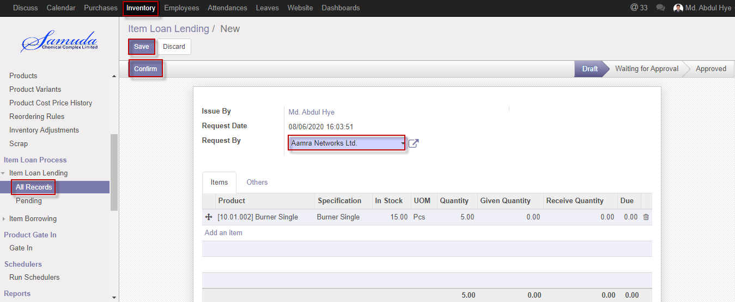

Figure: Item loan lending

## 13.2 Item loan lending Approved by Inventory Manager

Item Loan lending will be Edited & approved by Inventory manager.

Item loan lending approved using the menu **Inventory ‣ Item loan process>>Item loan lending** **>>Pending** and click **Approve.**

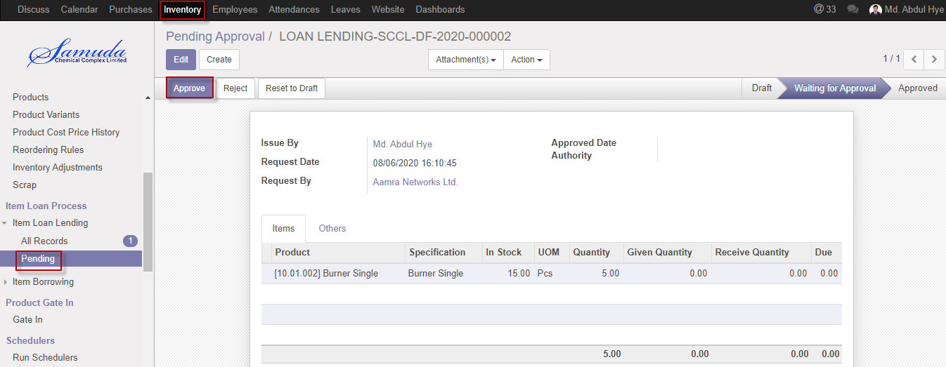

Figure: Item loan lending Approve

Reject item loan lending using **Reject** button

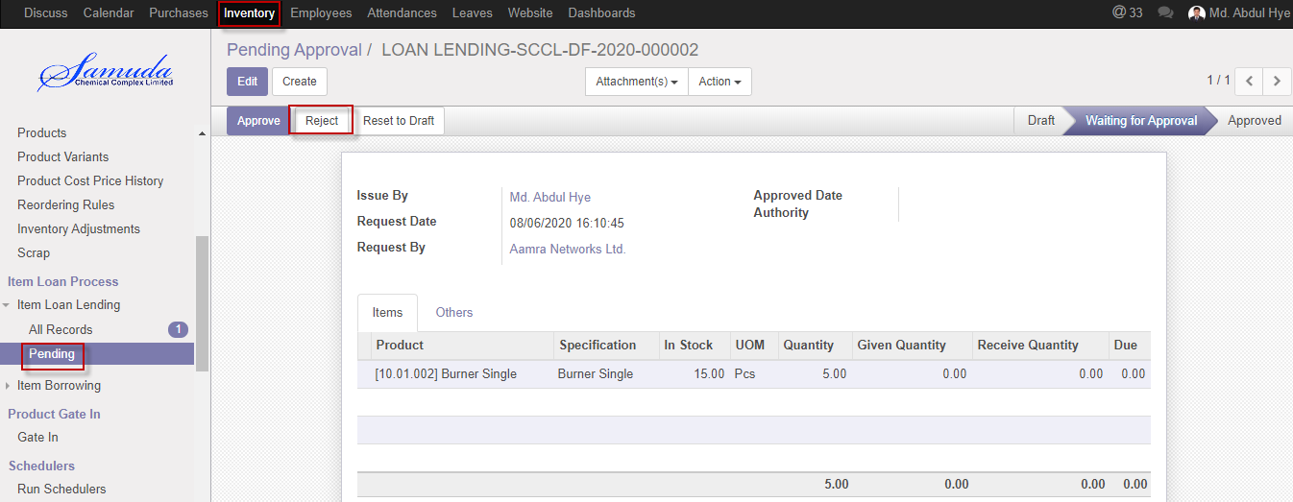

Figure: Item loan lending reject

# 14. Item Borrowing

Store keeper gives requisition for loan items. Plant manager will approve the loan request. Store keeper will receive goods against the loan.

## 14.1 Item Borrowing create by Inventory Manager

Item Borrowing will be Created/Edit by Inventory manager.

After borrowing Product qty will increase in Main stock.

Item Borrowing created using the menu **Inventory ‣ Item loan process>>Item borrowing>>All records** and click **Create.**

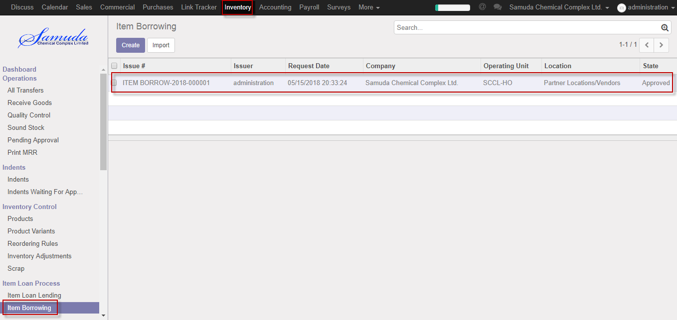

Figure: Item Borrowing List view

We need to set the following:-

**Partner Company**: Select Partner Company.

**Product:** Select product, after select other info will come auto.

After entering all information click **Save and confirm**.

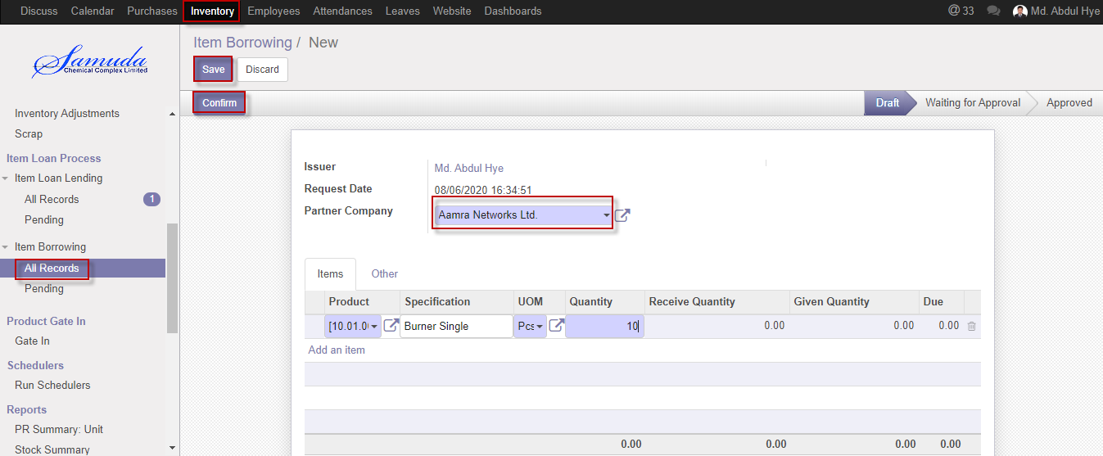

Figure: Item Borrowing

## 14.2 Item Borrowing Approved by Inventory Manager

Item Borrowing will be Edited & approved by Inventory manager.

Item loan borrowing approved using the menu **Inventory ‣ Item loan process>>Item Borrowing>>Pending** and click **Approve.**

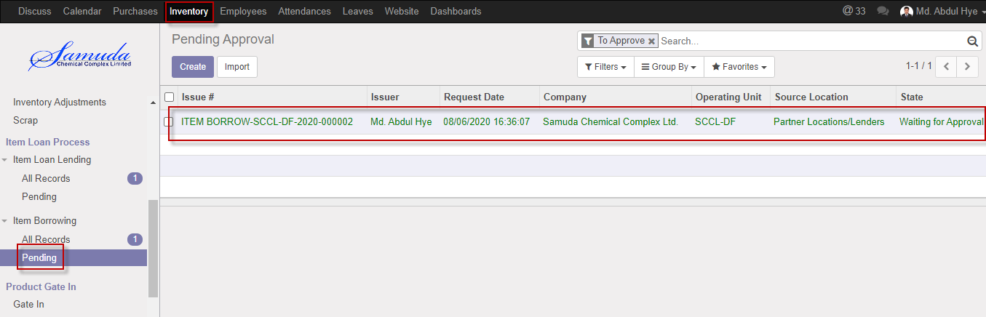

Figure: Pending Approval list view

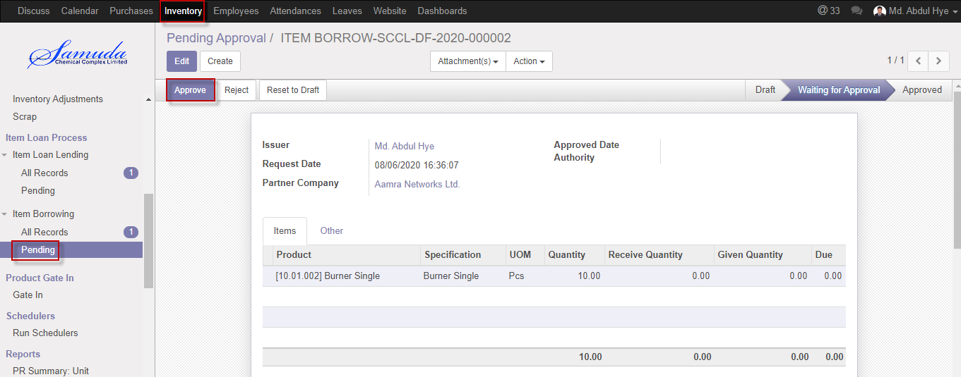

Figure: Item loan Borrowing Approve

Reject item loan borrowing using **Reject** button

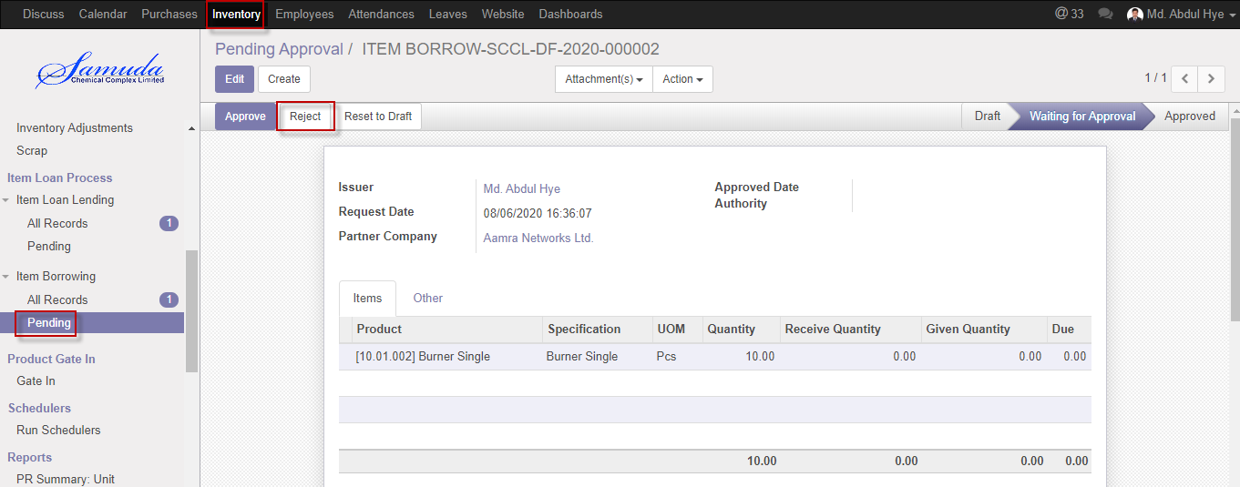

Figure: Item loan borrowing reject

# 15. Scrap

Scrap means waste that either has no economic value or only the value of its basic material

Content recoverable through recycling.

In your warehouse you sometimes find products that are damaged or that are unusable due to expiry or for some other reason. You often notice this during picking or physical inventory.

Since you cannot normally sell or store these products, you have to scrap product.

When goods are scrapped they are not reflected in the system as a part of the inventory. The scrapped material will be physically moved to scrap area.

## 15.1 Scrap create by Inventory Manager

Scrap will be Created/Edit by Inventory manager.

After Scrap Product qty will deduct from Main stock.

Scrap created using the menu **Inventory ‣ Inventory Control>>Scrap** and click **Create.**

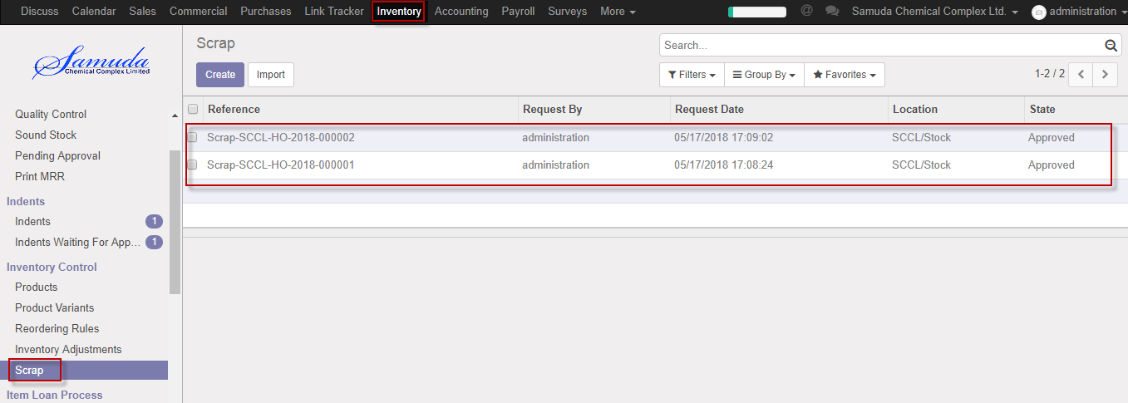

Figure: Scrap List view

We need to set the following:-

**Company**: Select Partner Company.

**Operating unit**: Select operating unit

**Location**: Select Location

**Product:** Select product, after select other info will come auto.

**Reason:** Enter specific reason for Scrap.

After entering all information clicks **Save and confirm**.

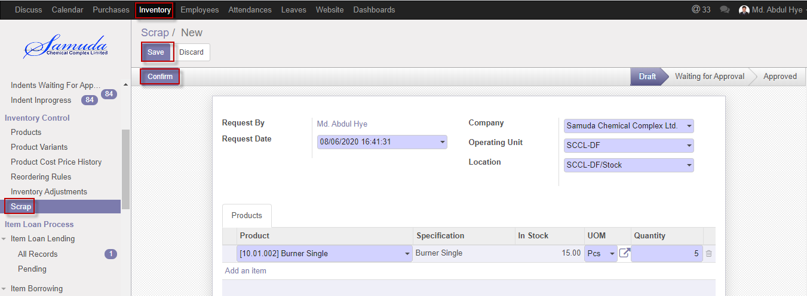

Figure: Create a scrap

## 15.2 Scrap Approved by Inventory Manager

Scrap will be Approved/Edit by Inventory manager.

Scrap Approved using the menu **Inventory ‣ Inventory Control>>Scrap** and click **Approve.**

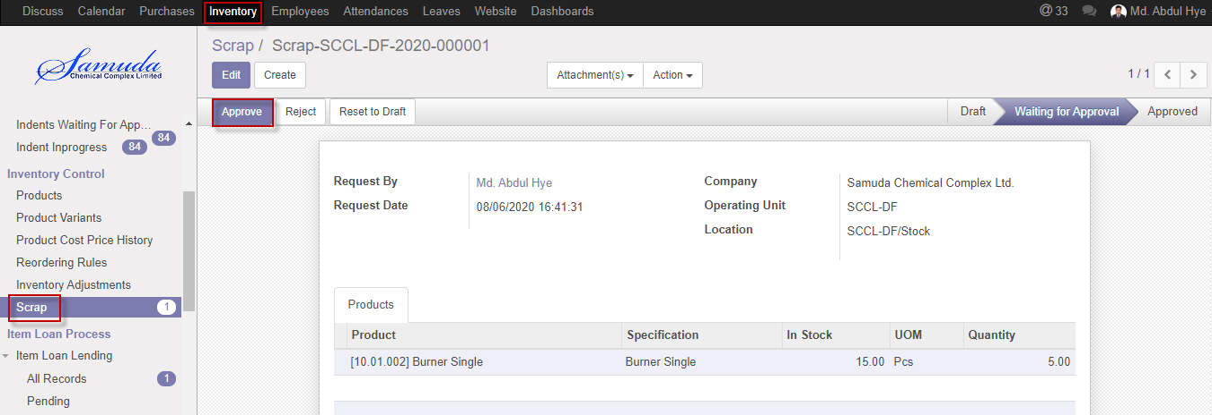

Figure: Approve Scrap

Click **Reject** button for reject Scrap.

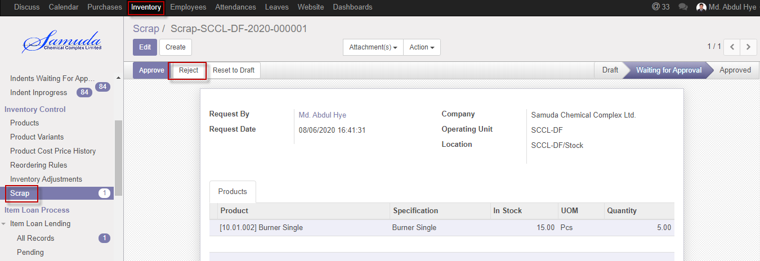

Figure: Reject a scrap

# 16. Reports

In Inventory module reports contain, Stock summary, Purchase reports, Stock transfer etc.

Reports document containing information graphic, or tabular form, prepared on ad hoc, periodic, recurring, regular, or as required basis.

## 16.1 PR Summary view by Inventory manager

Inventory user/manager will view PR summary reports if he/she wants.

To see the Stock summary reports use the menu **Inventory ‣Reports>** **PR summary**

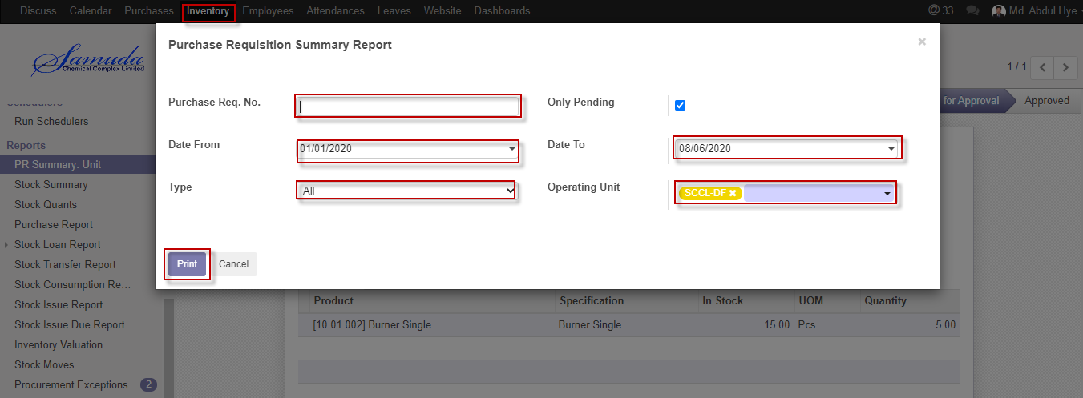

Figure: PR Summary reports print view

We need to set the following:-

**Purchase requisitions No**: Enter PR no.

**Date From:** Select date from.

**Date TO:** Select Date TO.

**Type:** Select type.

**Report Type:** Select Report type. Here will filtering report by Opening stock, Inward, Outward etc.

**Operating unit:** Select operating unit.

After entering all information click **Print**.

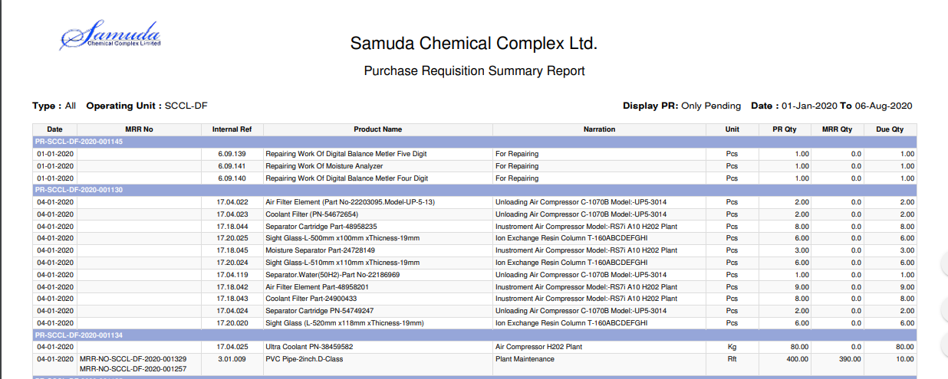

Figure: PR summary report PDF format.

## 16.2 Stock Summary view by Inventory user/manager

Inventory user/manager will view Stock summary reports if he/she wants. Here will show opening, inward, outward & closing Balance

To see the Stock summary reports use the menu **Inventory ‣Reports>** **Stock summary**

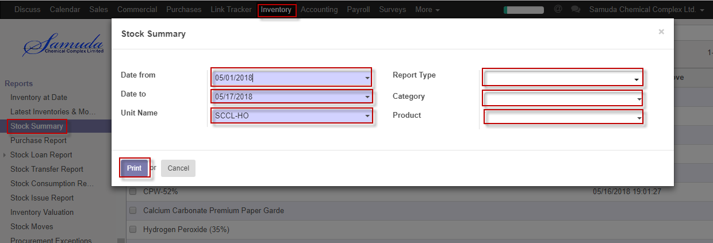

Figure: Stock Summary reports print view

We need to set the following:-

**Date From**: Select Date From.

**Date TO:** Select Date TO.

**Unit Name:** Select Unit name.

**Report Type:** Select Report type. Here will filtering report by Opening stock, Inward, Outward etc.

**Category:** Select Category.

**Product:** Select product.

After entering all information click **Print**.

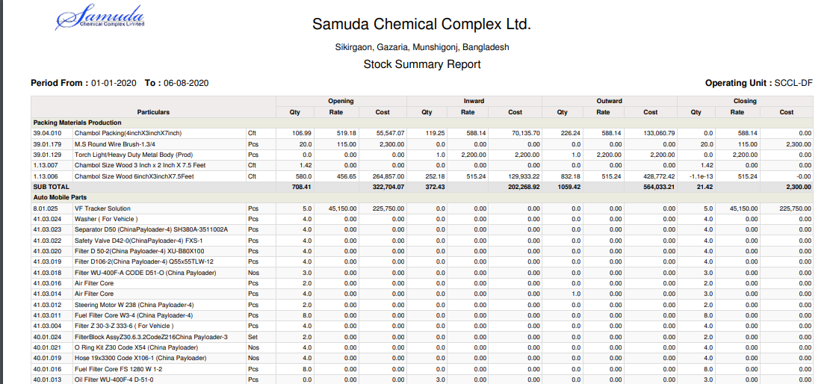

Figure: Stock summary report PDF format.

## 16.3 Purchase reports view by Inventory user/manager

Inventory user/manager will view Purchase reports if he/she wants. Here will show Purchase product information.

To see the Purchase reports use the menu **Inventory ‣Reports>** **Purchase Reports**

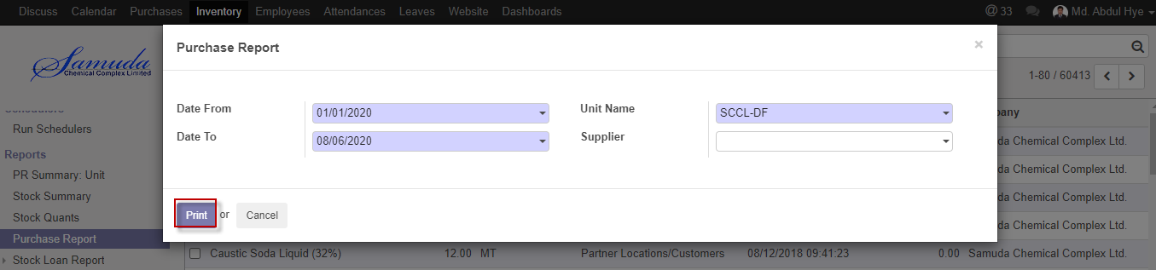

Figure: Purchase reports print view

We need to set the following:-

**Date From**: Select Date From.

**Date TO:** Select Date TO.

**Supplier:** Select Supplier.

After entering all information click **Print**.

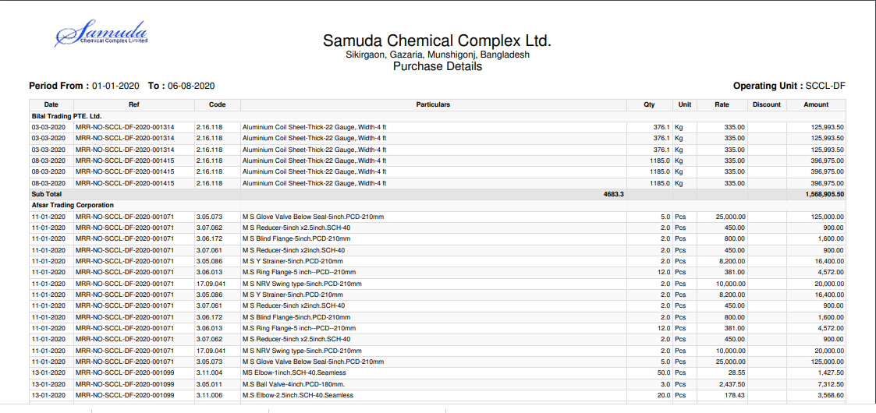

Figure: Purchase report PDF format.

## 16.4 Loan Lending Reports view by Inventory user/manager

Inventory user/manager will view Loan Lending reports if he/she wants. Here will show Company, Date, Operating unit wise, etc. Reports.

To see the Loan Lending reports use the menu **Inventory ‣Reports>Stock Loan Reports**>>**Loan Lending Reports**

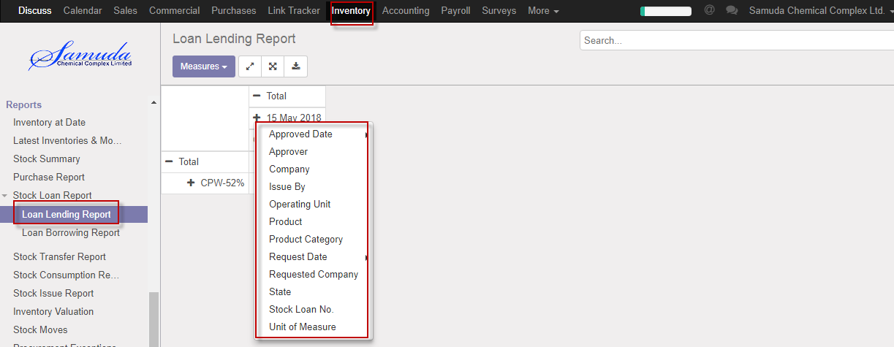

Figure: Loan Lending reports print view

We need to set the following:-

**Date**: Click Date expand button to expand reports. Then Select Company, Operating unit etc.

After entering all information click **Download button**.

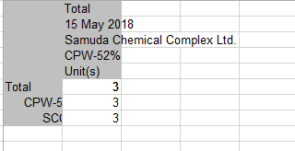

Figure: Loan Lending report Excel format.

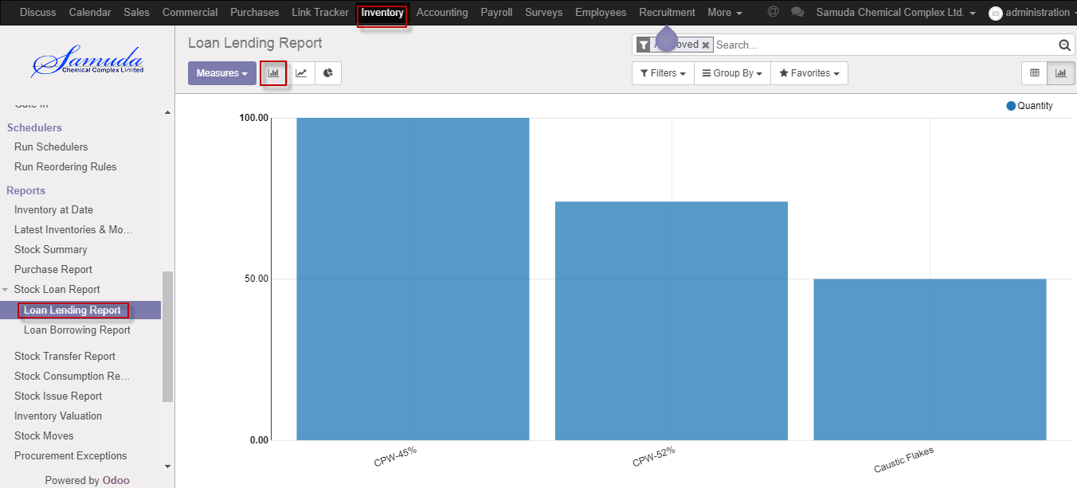

Figure: Loan lending Bar chart view

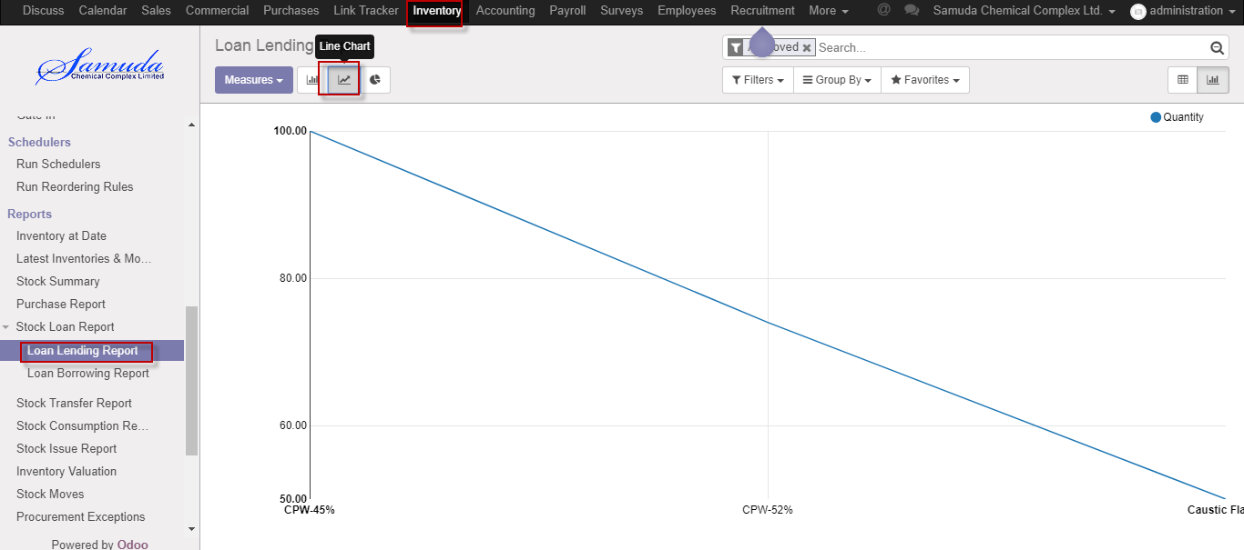

Figure: Loan lending Line chart view

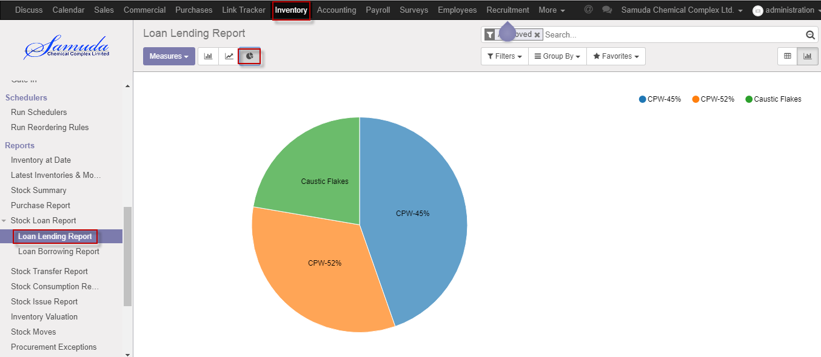

Figure: Loan lending Pie chart view

## 16.5 Loan Borrowing Reports view by Inventory user/manager

Inventory user/manager will view Loan Borrowing reports if he/she wants. Here will show Company, Date, Operating unit wise, etc. Reports.

To see the Loan Borrowing reports use the menu **Inventory ‣Reports>Stock Loan Reports**>>**Loan Borrowing Reports**

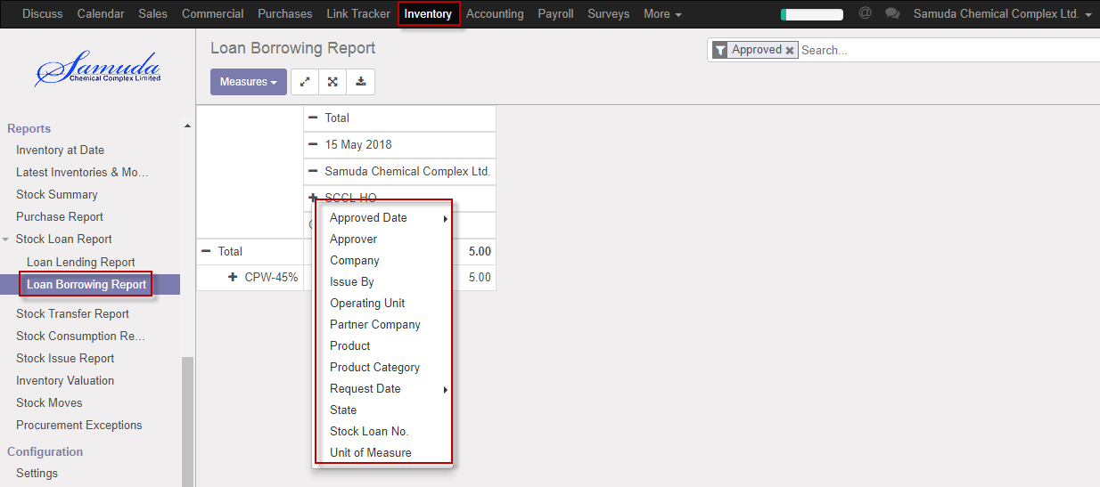

Figure: Loan Borrowing reports print view

We need to set the following:-

**Date**: Click Date expand button to expand reports. Then Select Company, Operating unit etc.

After entering all information click **Download button**.

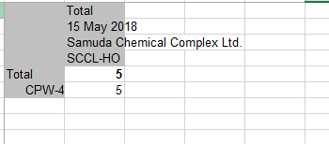

Figure: Loan borrowing report Excel format.

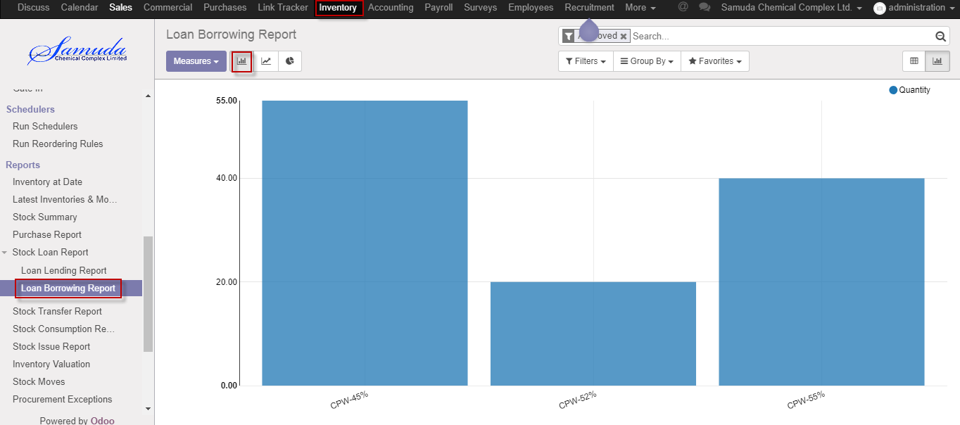

Figure: Loan Borrowing Bar chart view

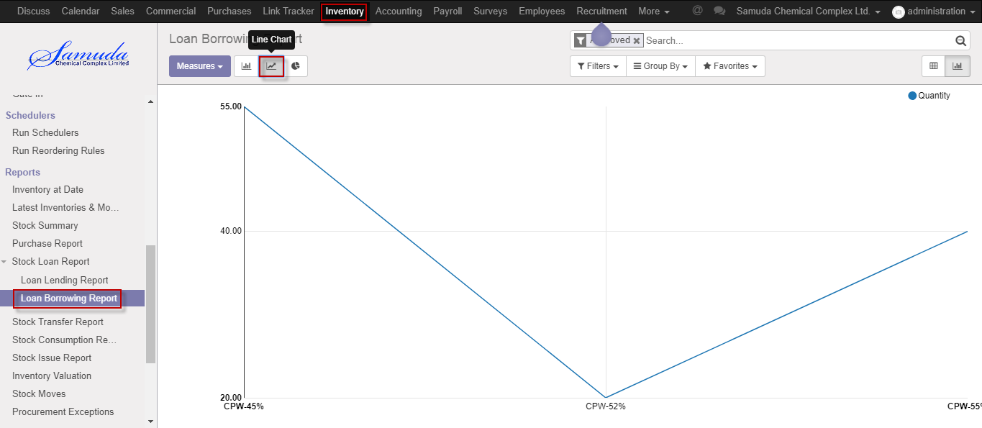

Figure: Loan Borrowing Line chart view

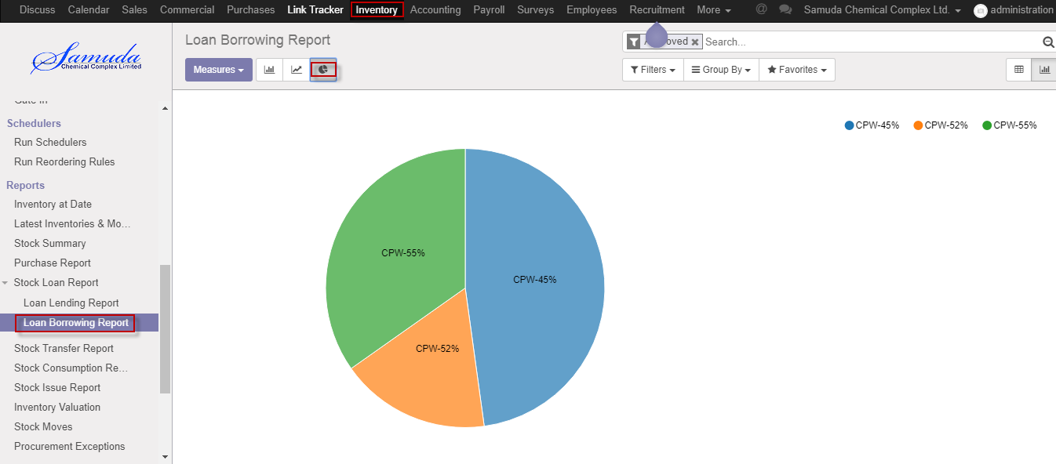

Figure: Loan Borrowing Pie chart view

## 16.6 Stock Transfer view by Inventory user/manager

Inventory user/manager will view Stock Transfer reports if he/she wants. Here will show Stock Move info one stock to another stock.

To see the Stock Transfer reports use the menu **Inventory ‣Reports>** **Stock Transfer**

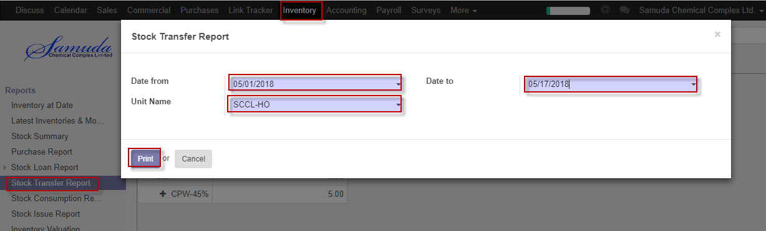

Figure: Stock Transfer reports print view

We need to set the following:-

**Date From**: Select Date From.

**Date TO:** Select Date TO.

**Unit Name:** Select Unit name.

After entering all information click **Print**.

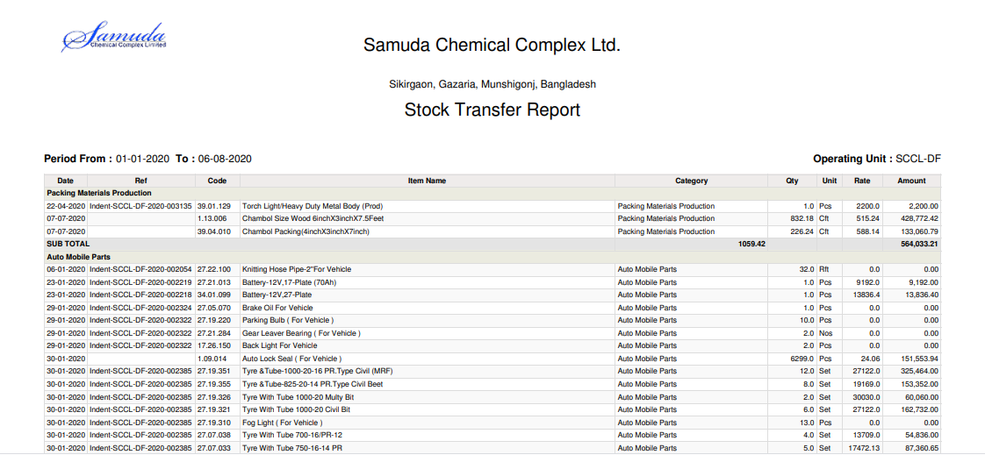

Figure: Stock transfer PDF format

## 16.7 Stock Consumption reports view by Inventory user/manager

Inventory user/manager will view Stock Consumption reports if he/she wants.

To see the Stock Consumption reports use the menu **Inventory ‣Reports>** **Stock Consumption**

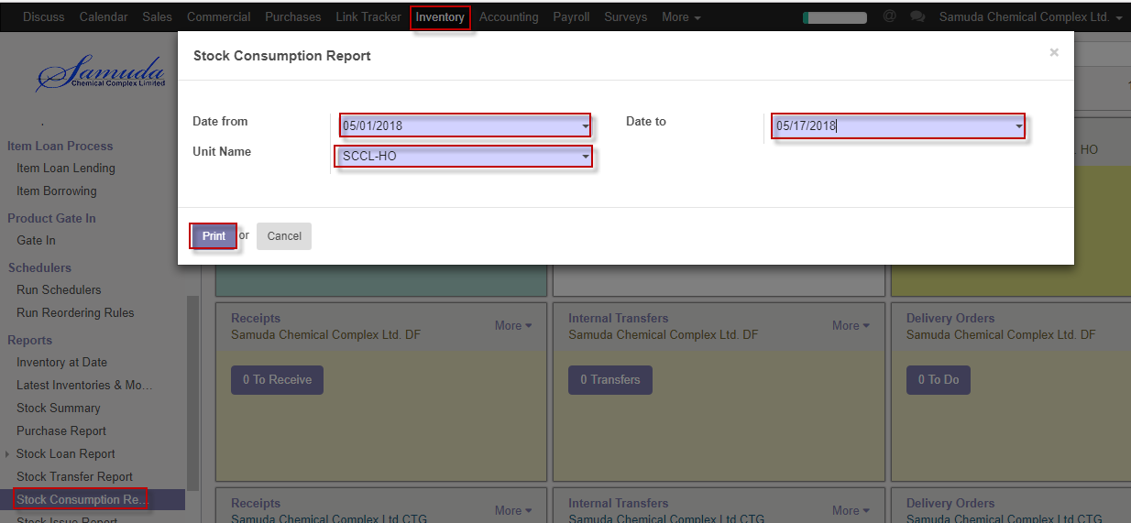

Figure: Stock Consumption reports print view

We need to set the following:-

**Date From**: Select Date From.

**Date TO:** Select Date TO.

**Unit Name:** Select Unit name.

After entering all information click **Print**.

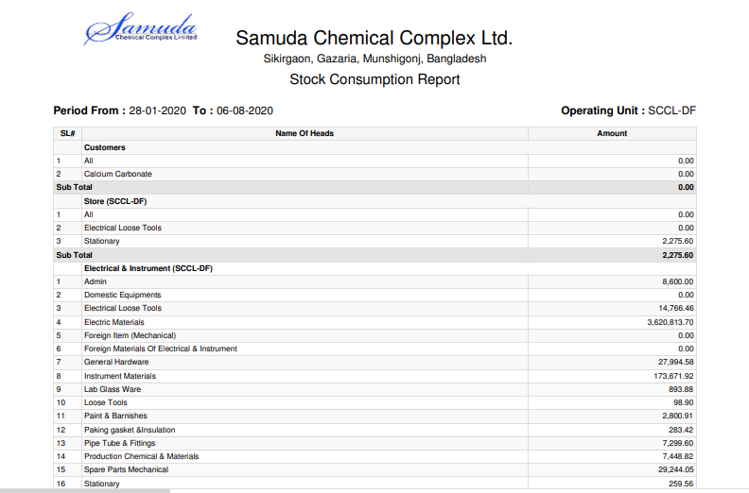

Figure: Stock consumption PDF format

## 16.8 Stock Issue reports view by Inventory user/manager

Inventory user/manager will view Stock Issue reports if he/she wants.

To see the Stock Issue reports use the menu **Inventory ‣Reports>** **Stock Issue Reports**

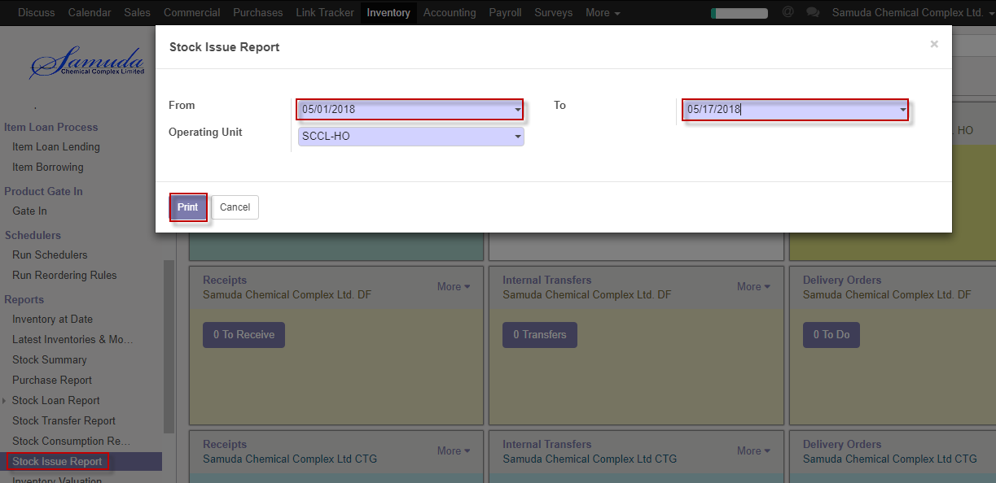

Figure: Stock Issue reports print view

We need to set the following:-

**Date From**: Select Date From.

**Date TO:** Select Date TO.

**Operating Unit Name:** Select Unit name.

After entering all information click **Print**.

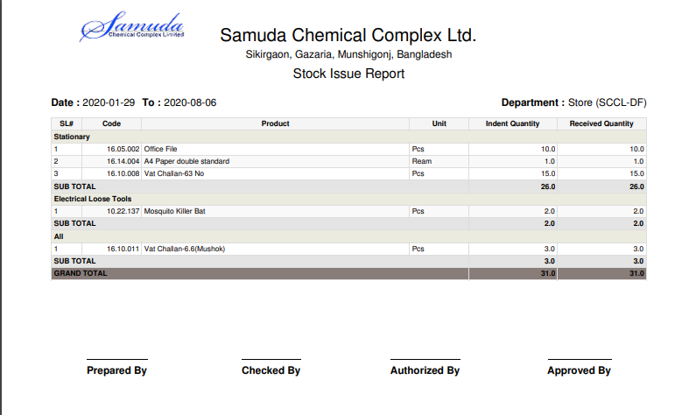

Figure: Stock issue PDF format

## 16.9 Stock Issue Due reports view by Inventory user/manager

Inventory user/manager will view Stock Issue due reports if he/she wants.

To see the Stock Issue due reports use the menu **Inventory ‣Reports>** **Stock Issue Due Reports**

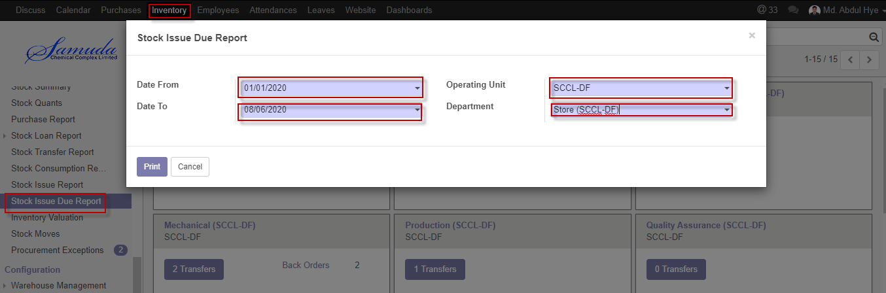

Figure: Stock Issue Due reports print view

We need to set the following:-

**Date From**: Select Date From.

**Date TO:** Select Date TO.

**Operating Unit Name:** Select Unit name.

**Department:** Select department.

After entering all information click **Print**.

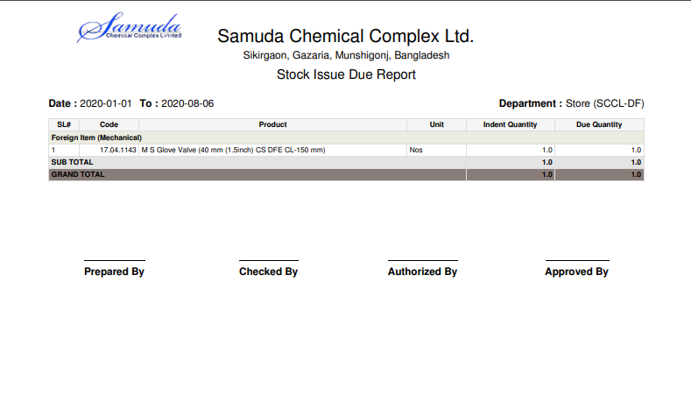

Figure: Stock issue due report PDF format